Destined
To Survive

Donald W. Dukeman’s

World War II Memoirs

Destined
To Survive

Donald W. Dukeman’s

World War II Memoirs

Unpublished work © Copyright 2002 by Donald W. Dukeman
First Edition
All Rights Reserved

Dedication

I dedicate these memoirs to my wonderful wife of fifty-eight years, and to our children, grandchildren, and great-grandchildren. I also dedicate these memoirs to Lieutenant Richard C. Scott Sr., who by the grace of God had the courage and skill to land the Baggy Maggy so that nine of the ten crew members survived. I also dedicate these memoirs to the memory of Tech Sergeant Bill Kirlin and other fallen comrades, to the crew of the Baggy Maggy, to families with questions and to all veterans. Finally, I dedicate these memoirs to future generations so that they may have a better understanding of the sacrifices made in order that they may enjoy the freedoms of today. As it is written in the National Holocaust Museum, “for the dead and the living...we must bear witness.”

Preface

It is my intent in writing these memoirs that there be an accurate account of my experiences during World War II, first as a young man seeing his country enter into world war, then as an enlisted man preparing for war, then as an engineer/gunner on a B-24 Bomber flying bombing missions into occupied Europe, and ultimately as a prisoner of war in Nazi Germany and survivor of a Nazi death march. Over fifty-seven years have passed since the end of World War II. It has only been within the past twelve years that I have had any contact with fellow crew members of the bomber named Baggy Maggy. As the years continue to pass, so do my fellow crew members. Today, only Larry M. Hewin, Richard C. Scott, George S. Burford and I live to recall those horrific memories of September 18th, 1944 and the days that were to follow.
I am writing these memoirs also at the request of my family. Prior to this, I have not talked much about these events nor the impact they have had on me. I had made some notes early on, but they were shared with few. Due to the passing of over half a century, there exists the possibility for some minor errors in this account. Nonetheless, I am writing this to the best of my recollection.
Finally, I’d like to thank Jos van Roozendaal from Holland for all his earnest efforts to memorialize the death of Bill Kirlin and the last flight of the Baggy Maggy. __________________________
Donald W. Dukeman, June 2002
Lancaster, Pennsylvania

Introduction

Donald Wayne Dukeman was born the 10th day of November 1923 in Lancaster County, Pennsylvania. He married Helen Pauline Piersol on the 19th day of February, 1944. Today, he is the proud patriarch of the Dukeman family, totaling thirty children, grandchildren, great-grandchildren and spouses.
The following account is that of a rural American boy who came of age as his country was at war with Hitler’s Third Reich, in what has become the last World War. For many of his family and friends, the details revealed herein may have never been heard before. For the longest time he has tried to forget those horrific images and experiences of war; however, as time passes by, so does the opportunity to educate future generations about the horrors of war and sacrifices made by others so many years ago. Hence, the writing of this, the personal memoirs of Donald W. Dukeman’s World War II experiences.
Destined To Survive takes you from the onset of America’s involvement into World War II, through Donald’s enlistment and basic training, to specialized training as a flight engineer/gunner on a B-24 Liberator bomber and then onto overseas assignment with a bomber crew. Several combat missions were flown throughout August and September 1944 before that fateful day arrived when the crew of the Baggy Maggy were forced to make a crash landing in German-occupied Holland. Surviving the crash, Donald was immediately taken prisoner of war by the Germans. The next five months of his life were spent at the hands of the Germans. Then in early February 1945, as the end of the war drew near, he was forced out of the prisoner-of-war camp to begin what would turn out to be an eighty-six day forced march, dubbed throughout history as one of the notorious Nazi Black Death Starvation Marches. Liberation eventually came in early May 1945.
Some fifty-seven years have passed since the end of the war. Donald has had the opportunity to rekindle some long lost friendships and reminisce of days gone by. He has completed these memoirs to the best of his recollection, and has made them available to family, friends, historians, and anyone who wishes to read them.
Finally, it has been a great honor for me to assist my grandfather with this endeavor. I have long had an interest in his service during World War II, and while growing up I can remember him telling me only brief accounts about the war. It was only within the last several years, since we began to document the memoirs, that I learned of the more horrific experiences he encountered. I’m proud of my grandfather, and I cherish the freedom he fought so hard for.

Gary Lee Dukeman, Jr., June 24th, 2002

The bombing of Pearl Harbor on December 7th, 1941, is a day that will never be forgotten in the history of the United States of America. I was eighteen years old and a junior at Honey Brook High School [Chester County, Pennsylvania] that day in December of 1941, and we could not believe what was coming over the radio on the news report. Although we were following the war in Europe all the time and were sure we would be involved before long, we never thought that the Japanese would do something so horrendous. Their delegates were holding peace meetings with our officials in Washington D.C. while they were bombing Pearl Harbor.
A lot of the fellows started to enlist in the different branches of the services, and the officials in Washington D.C. started to really get the draft system going in the country. I decided to quit school and enlist, but J. K. Lord, owner of the Chevrolet dealership in Honey Brook who served in World War I and was still in the reserves in the Navy, talked me out of quitting school so I could graduate with my class. I needed money to graduate the next year (senior dues, a suit for graduation, senior trip expenses, etc.) so in the spring of 1942, I got a job at Collins & Airman Plush Mill in Bondsville near Downingtown, Pennsylvania. The mill made canvas and wool uniforms for the Army. I was able to go to school in the mornings and then went to work at Collins & Aikman from 3:00 p.m. until 11:00 p.m. each night and still support the war effort.
In the spring of 1942, Clinton Smedley (who worked with me at the mill) and I decided to enlist in the Navy Air Corps because we knew that we would be drafted that summer. We knew that we did not want to be drafted into the Army, for that surely meant we’d be “foot soldiers.” I also had wanted to fly as a pilot. Clinton passed the Navy entrance qualifications, and I passed everything but the dental part of the physical. My teeth were in very bad condition, so the doctor told me to get them repaired, and then I would finally be accepted. The doctor also told me the Army Air Corps would take me with my teeth the way they were because the Army wasn’t as strict with their physicals. With these decisions on my mind, I returned home from Philadelphia and continued to work at the mill until the beginning of November.
Then in November of 1942, two of my school buddies and I went to Philadelphia. We arrived at the Old Customs House where Bill Romig and I enlisted in the Army Air Corps. The other fellow, Donald Hyman, chose to enlist in the Army Tank Corps. We had two weeks at home, and then we were to report back to the Old Customs House on the 20th of November to be sworn-in and placed into our respective service group outfits. On November 10th, 1942, I turned nineteen years old. Ten short days later, I bid farewell to my high school sweetheart, Pauline Piersol, and I was sworn in as a private in the United States Army Air Corps. After being sworn in, we were told we had four hours to wait before heading to the army depot where newly enlisted personnel reported for initial processing at New Cumberland, Pennsylvania. Since we had time, a few of us decided to go to a show at the Trok Theater [burlesque show].
We finally boarded a train in Philadelphia that traveled to the Army depot at New Cumberland, where we got six shots in our arms and one vaccination. We were then sent to the barracks for the night. The bunks there were double ones, and the fellows who took the top bunks couldn’t get up on them because the shots we had gotten in our arms left us without any strength. Some of the fellows fell flat on their faces when they tried to swing up onto the top bunk.
The next morning we were up early and told where we would head for our basic training. Bill Romig and I were sent to Kessler Army Air Field in Mississippi. Our basic training was for eight weeks. Unfortunately, I didn't see Donald Hyman again until after the war ended.

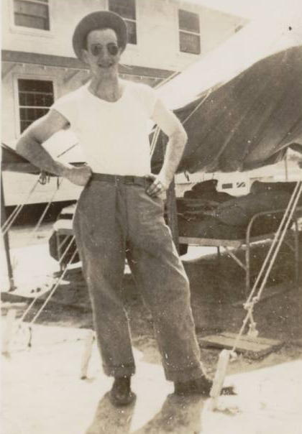
Basic Training

Upon arrival at Kessler Field, we were put in a tent city which became our home for eight weeks. We had to endure five-mile hikes with a full pack. Once we were used to those, we had twenty-five mile hikes with full packs. We camped out in the boonies for a week, doing our own cooking there, too. We ran the obstacle course, and did calisthenics every day. I had been in the Honey Brook Drum and Bugle Corps, as a bugler, for two years and knew how to drill and parade, so that part went easily for me. As a youth I had also been a boy scout, so the skills I learned there also helped me through basic training. I later helped our sergeant with the drilling of the men.
We also had intense firearms training. While we were on the rifle course, we had to qualify with the M-1 Garand rifle (.30-06 caliber). We had to take the rifle completely apart and put it back together while blindfolded. Towards the end of basic training we took a written aptitude test to see what we were best qualified to do in the Air Corps. They classified me to be an airplane mechanic, and I was assigned to the B-24 bomber school right there at Kessler Field.
Kessler field is located about 15 minutes by bus from the town of Biloxi, Mississippi. Upon completion of basic training, Kessler field then became my home for the next six months. I was assigned to go to school during the eleven p.m. to seven a.m. shift, and that wasn’t a very good time to go to school. Our barracks had two floors, and one floor was one shift and the other floor was another shift. Hence, the day-shift fellows would come into the barracks after three p.m. and we wouldn’t get to sleep until late in the day. After a couple of weeks that way the commander of the field made both floors the same shift so we would all be sleeping at the same time.
We started school at eleven o'clock p.m. The school covered everything from engines and electrical systems to hydraulic systems and the entire plane itself, inside and out. We got out of school at seven o'clock a.m. and went to breakfast. After breakfast we would go to the parade field and have calisthenics, marching, and close-order drilling.
I had appointments with the dentist every morning for a month and a half, so that tells you how bad my teeth were. I could go to sleep while the dentist was working on my teeth. Since I was at school all night and then all the other activity I had after school, it didn't take me long to fall asleep.
We had a Class-A pass after we started school, which gave us the opportunity to go into town on the weekends. If we had a grade of ninety percent or better, we could receive a two-day pass to New Orleans, which we worked very hard to get. Biloxi was a small town and the businesses would really fleece the soldiers over by taking their money on the days we got paid. Biloxi was allowed to have slot machines and other forms of gambling since this was permissible in Mississippi. On payday and for two days after, we could find slot machines in every place in town that you looked. On the third day after payday, you couldn’t find a slot machine anywhere in town.
A private’s pay began at $50.00 per month; then it went to $75.00 per month for a corporal. After making buck sergeant, it jumped to $96.00 per month, to just over a $100.00 per month for a staff sergeant. A tech sergeant made between $150.00 and $170.00 per month, plus an additional $50.00 per month flying pay once in combat. While I was working at Collins & Aikman I was making approximately $42.00 per week.
The trip to New Orleans took around four hours by bus. Two of us were lucky. One of our instructors had his own plane at nearby Gulfport, and since his wife lived in New Orleans, he flew to New Orleans every weekend. Consequently he took us along with him whenever we wanted to go to the big city. It took us one half hour to get to Gulfport, and just under an hour to get to New Orleans by plane. He flew us all over New Orleans the first trip, and what a sight that was. As we would say, it was a "soldier town." It was a little expensive to stay at a hotel, even in the forties, so we would stay at the Y.M.C.A. The rooms were comfortable and reasonably priced for us to stay in, and their food was very good (compared to the Army food). I only made three trips to the big city. During the other passes we loafed at the beach or in Biloxi itself. Kessler Field was supposed to be a mechanic school for the B-24 heavy bomber, but there weren’t any actual B-24s there for us to work on. We had engines that were similar to the Pratt & Whitney R-1830-43 used on the B-24D, and we also had mock-ups for the electrical and hydraulic systems, fuel cells, sheet metal, gun turrets, etc. to work on. The last week I was there the Army Air Corps received a real B-24 for the next training class to work on. However, this was a little too late for us.
I wanted to be on flying status, so I signed up for flight engineer training ("flying" airplane mechanic) and was sent to Ford’s Automobile plant at Willow Run, Michigan, which had been converted to make the B-24 Bomber. At this point Bill Romig headed for a different base, and I didn’t see him until after the war had ended.
After being promoted to a private first class (Pfc), I was stationed at Willow Run for six weeks, arriving two weeks before Easter of 1943. That was the closest that I got to my home, so I called my mother and my girlfriend and made arrangements for them to come out to Ypsilanti, Michigan (a town nearby) over the Easter holiday. At that point I had been away for six months and didn’t know when I would see them again, or where I'd be going next after I left Michigan. While they were there with me, Pauline and I became engaged.
I started school at Willow Run with a bolt and a nut that was used on a B-24, and I followed it through the entire plant until it became a B-24 ready to fly out of the hanger and into combat. I learned to do everything on the plane except help install the fuel cells in the wing. This job was done by dwarfs, because they were the only people who could get in the space in the wing to install the cells. If my memory serves me right, we put a bomber out on every 24-hour shift. The plant was running three shifts a day; a different shift started eight hours apart, seven days a week. Some of the responsibilities of the flight engineer were to transfer fuel in flight, check the instruments upon take off and landing, make any emergency sheet metal repairs during combat (e.g. if damage to the plane occurred), call the airspeed for the pilot, and read the power gauges.
Ypsilanti and Ann Arbor, nearby towns, were the two best towns to visit during my entire three years in the service. Our barracks were more like motel rooms, with two men to a room. The food was great, and they had special buses to take us into town. However, we didn’t use them very often because the civilian workers from the plant would pick us up and take us into town. When we were in town, the townspeople catered to us. They were very friendly and hospitable. Everything was mostly free to us, movies, dances, etc, and when we ate in town the people in the restaurants would pay for our meals.
After completing the training at Willow Run, I was now classified as a flight engineer, rank of corporal. Now that I was a flight engineer, I was then sent to gunnery school at Harlingen Army Air Force Base, Texas in June 1943.
Harlingen was just a few miles north of Brownsville, Texas, which was right on the border of Mexico. When we left Willow Run, we were considered flight engineers and had to take gunnery school because our job in combat was to man a gun turret. Most of the flight engineers were top turret gunners, because our controls were on or around the flight deck just below the top turret. Hence I would become a top turret gunner on the B-24. Our training at gunnery school involved everything from firing an air rifle to firing a fifty-caliber machine gun. We fired on the ground and in the air from an AT-6 airplane. The AT-6 was a twin seater, single-engine training aircraft that the military used to train gunners. We fired .30 caliber and .50 caliber machine guns at targets that were pulled by other AT-6. We had to disassemble all the guns we were instructed on including the automatics (Colt .45 pistol), M-1 rifle, Thompson submachine gun, .30 caliber carbine rifle, and the .30 caliber and .50 caliber machine guns. Then we put them back together and made sure they would fire and cycle ammunition. During my training I qualified for the Marksman badge.

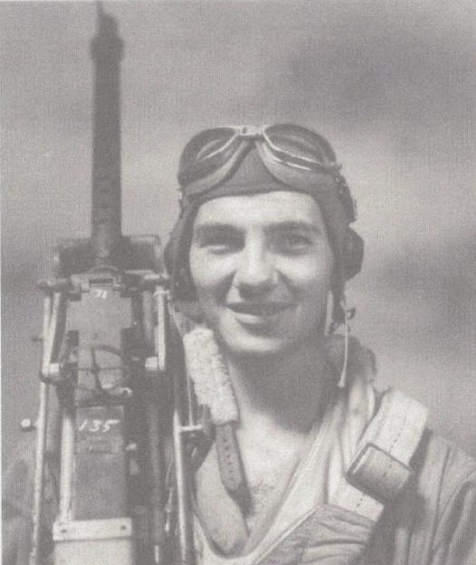
Gunnery school graduation

While I was at Harlingen, the Army lowered its standards for those wanting to qualify for the aviation cadet training. This training was for those who wanted to become pilots, bombardiers, or navigators. Since we were at war, the Army especially needed pilots. The previous standards included attending four years of college and passing the written tests. The new standards consisted of passing only the written examinations. I took the tests while I was in gunnery school and passed the tests. I was accepted into the cadet program. Aviation cadet training would entail another basic training course, college, classification, pre-flight school, and then finally flight school. I graduated from gunnery school on July 31st, 1943 and received my gunner wings and another stripe, making me a buck sergeant.
In August 1943, one hundred and five of us were sent to Amarillo, Texas, to take another basic training course: the first part of the Aviation Cadet Training program. We had another eight weeks of basic training (including the physical fitness exercises and drill) and no passes until we were finished with our training. Amarillo, Texas, is approximately eighty miles south of the Oklahoma border. I think it was the worst place we stayed there in Texas. It was over 100 degrees during the day, and at nights we thought we would freeze. We would go to bed at nights with our wool blankets over us and the next morning we woke up with about an inch of sand all over us. During the day, the winds blew the sand into Oklahoma, and at nights it would blow back into Texas. This happened night after night the entire eight weeks we were there. We were sure glad when we were ready to be shipped out to the college program at the Central College of Washington, in the city of Ellensburg, State of Washington. We finished our basic training, and then we received our twenty-four hour pass to town. When we got back to camp, we were at camp for a couple of days before we got our train for Ellensburg, Washington.
We left by way of Colorado and stopped in Denver for several hours. I had a great uncle living there, but I couldn’t find his telephone number. Later I found out it was unlisted, so I never did get to meet with him. Still in Denver, several of us decided to get a decent hair cut from a regular civilian barber while we had time. We had to have a ¼ inch hair cut because we were in the cadet program. I got a haircut and when I went to pay for it, I only had a twenty-dollar bill. Guess what? I received eighteen silver dollars in a bag as change because out there they only used silver coins. Some banks at that time didn’t even have paper money. Here it was the nineteen-forties, but progress was not moving as fast in the “wild west” as it was back home on the east coast.
We finally left Denver and headed for Washington. This was some experience traveling on the troop trains. They were usually older trains, steam engine powered with old dirty cars that we rode in. We took all the back tracks, stopped at all the crossings, and stopped every time another train approached in order to let the other trains go by us. This was not only a matter of courtesy but also a necessity in that our trains were much slower than the commercial trains; had we not moved, we’d have backed up trains from Colorado to Washington.
Shortly after dinner the train pulled into a siding (a side track running parallel to the main track where a slower train could pull over and let a faster train go by) and stopped. The officer who was in charge of us told us we would be there for a while because the engine blew its boiler, and he didn’t know when we would be leaving. We had passed a small village back aways, so we asked if some of us could hike back to the town. We were told we could because we might be there all day and night before we got another engine.
I guess there were about ten of us who took off for the no-name town. When we got there, there were about six houses and one store in the town. We went to the store, and what a store it was! You talk about old: it was like one of those stores you would see in the old western town movies. We were hot from the walk to the town, so we headed for what looked like a soda cooler. It was a cooler all right, but nothing in it was cold, or even a little cool. Come to find out they didn’t have electricity, nor did they have any ice. What a joke on us.
The old man who owned the store treated all of us to whatever we wanted. He wondered if we should take anything back to the train for the other soldiers (drinks, candy, etc.) It was quite an experience of kindness for us, but he got a bigger experience talking to us soldiers because he had never seen a stranger or a soldier before. We did get some sodas; however, we declined his offer to take some back since there were one hundred and five of us on the train. We finally got back to the train and waited some more until the other engine finally arrived an hour or so later. All in all we spent the better part of the day waiting for the other engine to arrive.
We arrived at the Central College of Washington, Ellensburg, Washington in the fall of 1943. We were the first military cadet class to start at the college. Prior to this, the college did not have a military cadet program. Rather than building more schools of their own, the military began enrolling cadets in civilian colleges. In addition to basic college level courses, we had more drill and physical fitness exercises. There were one hundred and five of us soldiers, and around four hundred and fifty to six hundred coeds at the college. There was one civilian disabled boy, and the rest of the male population were cadets.
Ellensburg and nearby Yakima were also soldiers’ towns. Movies, dances and other activities were all free to the soldiers. If you kept your nose clean all week and had no demerits, you would have the weekend off. The housemothers for the coeds had the history of all of us soldier boys. This included our home states, family information, the towns were we lived, our religious background, etc. all on record. They wanted to know who was spending time with their coeds. If we were free of duties for the week, we could be asked out by the coeds that lived in Ellensburg, and invited for a meal at their homes sometimes either on a Saturday or Sunday.
The cadet training was really strict. We paraded to all the functions. We couldn’t even look at the girls when we were outside our dorm, at school, or in the halls of the college. They would line the sidewalk as we marched by and whistle at us. If our Cadet-Majors saw an eye blink or saw an eyeball look sideways, we were gigged for the weekend. This meant we had to walk the perimeter of either the sports field or the entire campus for so many hours over the course of Saturday and Sunday. Although others had to do it, I never had to walk the perimeter.
While we were at college, we also received ten hours of flying in a Piper Cub aircraft. This was a preliminary test to see if we could continue in our quest to fly. They’d check to see if we had coordination and good reaction time. Obviously, if you were afraid to fly, then you were washed out of the program. The latter preflight training was very expensive for the military; thus this brief exposure to flight was a means to begin the screening process. Our next stop would be classification and preflight training at Santa Ana, California.

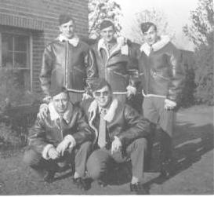
Pilot Hopefuls
Back row, from left: Doyle, Hill, Dukeman.
Front row, from left: Denny, Holden.

We left Ellensburg the evening of December 31st, 1943, by train for Santa Ana, California. We were lucky this time. No troop train; rather, we rode on a regular train, so we got to California a lot faster than the last train ride. When we arrived at Santa Ana, we had twenty-four hours before we had to go to the base. Some of us got a room at the Y.M.C.A., and others got rooms at a hotel. Sightseeing helped us check out this new town.
We reported to the base on the date that was on our orders, and the very next day we had inspection. This was considered normal when you changed bases. We were told to get our hair cut, so we went to the base barbers. There were two fellows right out of civilian life that went with us for their haircuts. This turned into a circus. When the one fellow with blonde curly hair got on the barber chair, he told the barber just how he wanted it cut. The barber took the clippers and started at one ear and went up and over his head to his other ear. It was also shorter than the standard ¼ inch. The barber then went from the back of his neck to his forehead, making him look like an Indian. The fellow had tears in his eyes, but that was the army.
Classification consisted of a lot more written tests, physical examinations and a lot of interviews (psychological) which could make or break a person with the questions they would ask you. Some of the fellows washed out of cadets from those questions alone. The interview was to show what your mental limits were and how much verbal abuse you could take. Sixty-five of the one hundred and five of us who were in college together washed out at classification. Previously we had three choices to make: did we want to be pilots, bombardiers, or navigators. All of us wanted to be pilots. Sixty-five of us did not make a second or third choice because we did not want to be bombardiers or navigators if we weren’t selected to be pilots. As a result, the Army washed all sixty-five of us out. The ones who made the other choices ended up being bombardiers or navigators, as the need for pilots was not critical at that time. Since most of us had already been trained for other duties, we were given fourteen days leave to go home.
Gee, this was great: getting to go home even if it meant heading for a combat theater. I got home on a fourteen-day leave, around the 11th or 12th of February 1944. Several days later, Pauline and I decided to get married. Normally to get married you had to wait three days for a blood test and get the marriage license from the courthouse. However, my father had his lawyer intercede for us because we were running out of time. We got our blood work done in the morning, and that afternoon we picked up our marriage license at the courthouse and were married on the 19th of February. I left home and reported to Salt Lake City, Utah, on the 25th of February 1944.

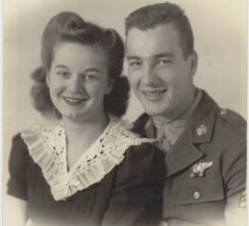
Happy Newlyweds

Arriving at Salt Lake City, I was assigned to Joseph Digman’s crew. The crew members were as follows: Joseph Digman, pilot; Forrest Holbrook, copilot; Forrest Lam, navigator; Robert Brooks, bombardier; Malcom Moore, radio operator; Arnold Anderson, second engineer & waist gunner; Lawrence Wilcox, ball gunner; Clinton Thornhill, waist gunner; John David Jr., armor & tail gunner; and myself as flight engineer & top turret gunner. We were then sent to Casper, Wyoming, where we finally flew the B-24 and received our final combat training. We had three months of training there, so I called home and had my wife come out to Casper to stay for the three months with me before I headed for combat.

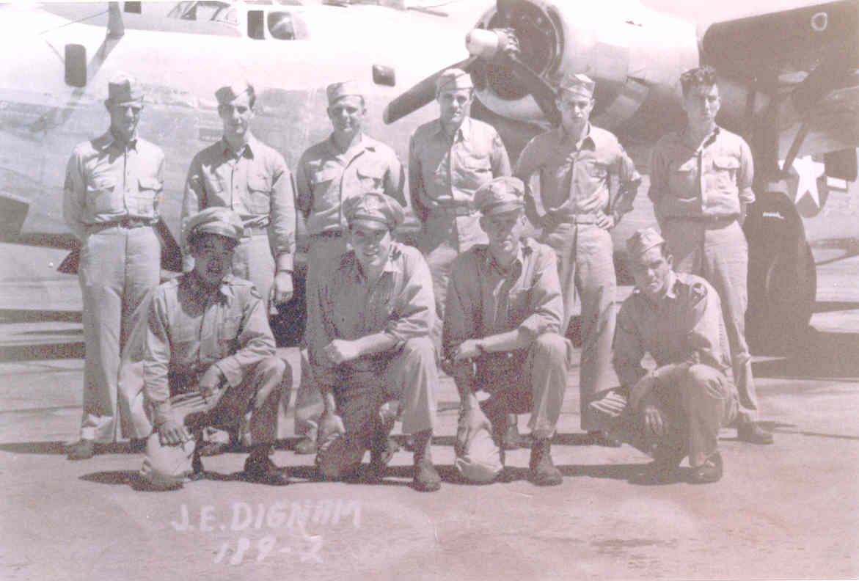
The Digman Crew.
Back row, from left: John David Jr, Donald Dukeman, Arnold Anderson, Clinton Thornhill, Malcom Moore, Lawrence Wilcox.
Front row, from left: Forrest Lam, Joseph Digman, Forrest Holbrook, Robert Brooks.

Casper, Wyoming is a real western town with cowboys and Indians. Every time you saw the cowboys, they had their guns strapped to their legs, and on some Saturday nights we would hear gunfire erupting on the streets. They may not have been in town for weeks, so when they finally did get to town there was often a lot of celebration going on. The first time we heard this shooting, we didn’t know what was going on. They would really celebrate, horseback and all.
Pauline arrived at Casper about one week after we got there, and wondered what she had gotten into out there. She only saw cowboys in the movies back home, not in a real live western town that Casper was.
At Casper I received turret gunnery training, and finally got to fire the twin 50s of the top turret. On the later model B-24s, such as the B-24D and B-24J models, the top turret was electrically operated. It not only fed the rounds automatically, but the turret spun and the guns moved at the push of a button. The B-24Js that I would later fly in had the Martin Electric top turret. Our crew flew training missions both during the day as well as cross-country at night. We flew bombing missions, dropping real bombs on targets on the ground. The gunners had live ammunition and also fired at targets on the ground. This sometimes included cattle, deer, and antelope, but no horses were ever killed by the airmen. After this happened a couple of times, our Commander of the Casper Air Base put out an order that $1.00 per pound would be charged for all livestock killed from airplanes. We all used differently colored painted bullets, so each crew could be identified, and charged for the kill. This order stopped the killing of the livestock.
One of our night flights was to Houston, Texas, and back to Casper which took us over four hours. Just around the Texas border, we ran into an electrical storm, and none of us had ever been in a storm in an airplane before. What an experience that was, with lightning flashing all around the plane and a blue haze around each engine. It got a little scary at times. We had one of the best navigators, though. We rode the storm out almost all the way back to Casper, and Joe asked Lam if he knew the way back to the field. Lam gave Joe a compass heading to follow and after so long we should see the landing light on the field. Guess what? Lam had us coming in right on the runway. All Joe had to do was lower the landing wheels and set us down on the runway. After that, Joe never again asked Lam if he knew where we were. To this day, I still think Lam was one of the best navigators the Eighth Air Force had.
We finished our training at Casper, and I was then promoted to Staff Sergeant in June 1944. Shipped off to an air base in Topeka, Kansas, we then picked up one brand new B-24J to fly overseas in. We were all issued summer clothes, mosquito netting for around our beds, a .30 caliber carbine rifle, a Colt .45 automatic pistol, and summer flying gear (a light jumpsuit). The military took all the winter clothes we had. This sure made us think we were going to the South Pacific. This took us a week to do, and we could have done it in a day or two, but no one was complaining because we were still in the good old U.S.A.
Since we were issued a new plane [unknown serial number], we expected to keep it as our own plane when we finally got to an assigned base, so we had to have a picture painted on it (nose art) just like some of the other planes sitting on the ramps at the base. Our picture was called the Nut-Cracker Sweet, and it cost us one hundred and twenty-five dollars. It was a very nice paint job. It sounds like a lot of money, but ten fellows paid for it, so that wasn’t bad for each one to pay. We still didn’t know where we were going, but it sure looked like the South Pacific. The last day stateside they told us the briefing would be early the next morning. The briefing was on June 26th, 1944, and we were advised we'd be heading across the North Atlantic, by way of Bangor, Maine, to Goose Bay, Labrador, to Meeks, Iceland, and then on to Stone, Wales, with the final destination being England.

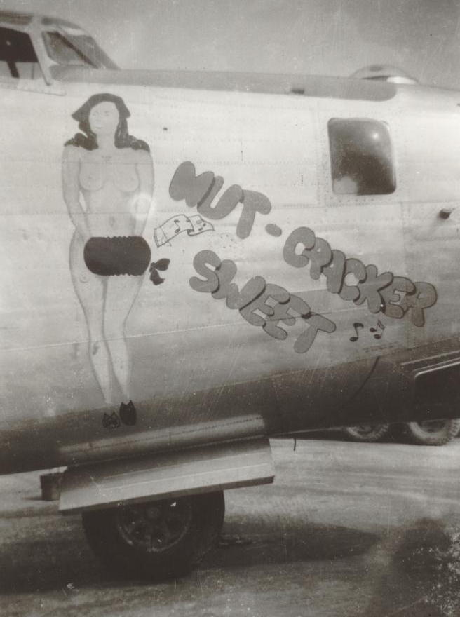
Nut-Cracker Sweet

On June 28th, we took off from Topeka, Kansas, and headed for Bangor, Maine, which would be our first stop. That night, when I went for a shower, I put my wallet under my pillow. The next morning I got up and went for breakfast, and then out to the airplane to get it ready to leave. The rest of the crew eventually came out, and we left. About an hour into the flight I realized I didn’t have my wallet. We couldn’t turn back, so the radio operator called back to the field and told them about the wallet. Someone there went to the barracks and got it and sent it home to Pauline. From that time on I never received any pay until I came home from Germany after the war was over. The military paid by the month and we'd already received July's paycheck. Then, for whatever reason, we didn't get one in August. My copilot loaned me some money, but I never got the chance to pay him back because I never received pay while I flew with them.
We had great flying until we landed at Meeks, Iceland. There we were sacked in with bad weather, and had to stay another day before we could finish the trip to Stone, Wales. We landed at Stone on the fourth of July, and the Army took our new airplane away from us after having flown it entirely across the North Atlantic. Unbeknownst to most crews, immediately upon arrival in England, newly arriving aircraft were sent to depot to be modified for combat. I later learned that the Nut-Cracker Sweet went to the 7th Bomb Group, 493rd Bomber Squadron (or 492nd BS by some accounts) in Burma. It was also a common practice that once a new plane arrived overseas it was reassigned to a lead crew or senior crew, thus the newly arrived crews often flew the older planes. This was referred to as "plane swapping."
We left Stone by train and went to Warrington, England, staying overnight there. The next day we went to New Castle, Ireland. There we had two weeks of final training for combat. The training consisted of more gunnery training where they had .50 caliber machine guns mounted on trucks and jeeps. You'd fire the guns at targets on land as you were moving. This simulated the movement encountered in flight. We also had classes in airplane recognition, and presentations from veterans who'd fought thus far in the war.
We were finally assigned to the 8th Air Force, 2nd Air Division, 20th Combat Wing, 93rd Bomb Group, 409th Bomber Squadron at Hardwick Air Base in England. We were assigned to the airplane named R. Roger, a B-24J [unknown serial number] which had just “R. Roger” painted on the nose. It was not the Roy Roger, rather I feel it may have been named after a previous crew member or perhaps a crew member’s relative.

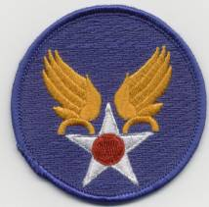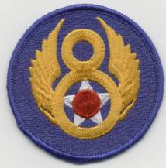
U.S. Army Air Corps Eight Air Force

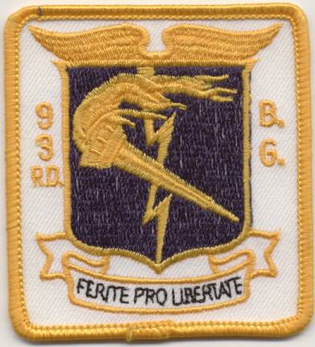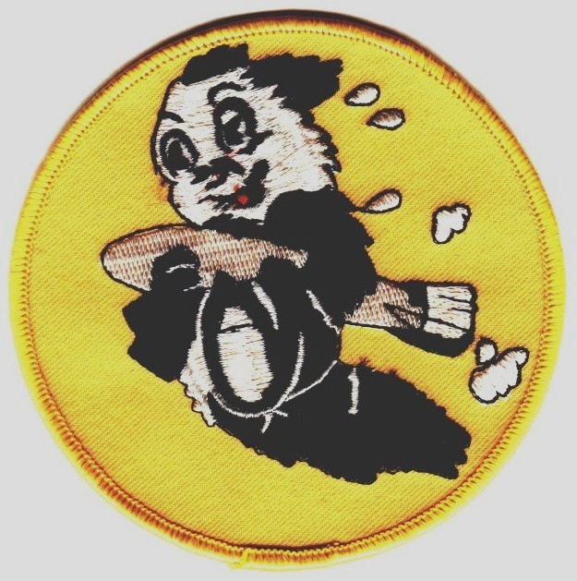
93rd Bomb Group 409th Bomber Squadron

The B-24J had a height of 18 ft, wing span of 110 ft, and length of 67 ft 7.6 inches. It could carry payloads up to four 2,000 lb bombs, or any combination of the following ordnance (up to 8,000 lbs total capacity): 1,000 lb bombs, 500 lb bombs, 200 lb bombs, shrapnel bombs, delayed fused bombs, or incendiary bombs. Typically the armament we had consisted of twin fifty caliber machine guns (Browning M-2 air-cooled) in the top and bottom turret, single fifty caliber machine guns on either side as "waist gunners," twin fifty caliber machine guns in the tail, and two to three fifty caliber machine guns in the nose turret. The aircraft was powered by four Pratt & Whitney R-1830-65 radial air-cooled engines. Each engine capable of producing 1,200 horsepower for a maximum air speed of 290 m.p.h.
The B-24 was used for long-range bombing missions. Its range was reportedly 3,000 miles. It was often dubbed the "flying boxcar" for its shape. However, this heavy bomber was one of the most dependable aircraft of World War II. We flew at an altitude under 200 feet (tree-tops) with an average of 12,000 - 15,000 feet, to as high as 28,000 - 30,000 feet. Any flights over 10,000 feet required us to don the oxygen masks, as the B-24 was not pressurized. If you were in your position, you’d simply put on your mask and plug into the oxygen outlet at your position. The oxygen was then supplied via large yellow oxygen bottles. If you were mobile inside the plane, then you’d have to plug into one of the portable tanks, strap it on, and carry it with you.
Another dilemma of high altitude flying in those days was exposure to freezing temperatures. Lacking pressurized compartments, the temperature easily dipped as cold as forty degrees below zero at higher altitudes. Thus, there were “cold suits” to protect us and keep us warm. These suits are similar to the electric blankets of today. They consisted of heating wires inside the suit, that when plugged into the plane’s electrical outlets, they’d heat up and keep you from freezing; at least that’s what they were supposed to do. It seemed more often then not, they’d short out and either shock you where the wires bent (such as in the elbow area) or worse, they’d catch fire from a short in the electrical system.
There were usually at least six bombers, sometimes as many as twelve, that flew in a wedge formation. Multiple bomb groups consisting of hundreds of bombers often flew in the all-out raids such as D-Day and Ploesti. The U.S. Army Air Corps preferred daytime high altitude strategic (or often called precision) bombing. The British preferred nighttime saturation bombing.
Often our targets were German airfields, where we destroyed their fighter and bomber aircraft and bombed their runways. If a runway was littered with craters, then the remaining aircraft couldn't take off; neither could others land there until repairs were made. Additionally we'd bomb bridges, railroads, and rail hubs or marshalling yards (where additional train cars were stored) so that the Germans couldn't resupply their troops. V-2 rocket factories and ball bearing plants were also important targets to bomb. German oil dumps were bombed, for these were fuel storage locations destined for the German war effort (fuel for tanks, trucks, airplanes, etc.)
There was always the potential to come up against German fighter aircraft during one of these long-range missions. German fighters known to be in this area were Messerschmitt (ME) 109s, Messerschmitt (ME) 210s, and Focke-Wulf (FW) 190s. German ground fire often consisted of 20mm and 88mm antiaircraft flak guns, which in the hands of the battle hardened German gunners proved to be very accurate and dangerous. The 88mm Flak gun could fire fifteen to twenty-five rounds per minute. The round had a velocity of 825 meters per second with a maximum shot altitude of 14,700 meters, and maximum range of 19,800 meters. Many crews experienced damage to their aircraft by flak because once we were neared the bombing target, the pilots took no more evasive action until bombs away. In essence we held formation and continued at the same airspeed, altitude and direction until the bombs were dropped. This often exposed crews to flak and enemy fighters.
Our first combat flight was on Tuesday, August 1st, 1944, with a destination near German-occupied Joigny, France. We flew at an altitude of approximately 15,000 feet and bombed an airfield destroying German aircraft and runways. We also bombed an oil dump on this mission. We didn’t see any German fighters, but we encountered heavy and accurate flak. The flying time for this mission was seven hours. When we got back to the base, the Crew Chief (ground mechanic) for the airplane we just flew and I counted the holes in the airplane. There were one hundred and five holes from the flak we had flown through on this mission. I recall the number of holes, because I had to assist the ground crew in patching them all. This was a good beginning for us. None of the damage was severe enough to cripple or down the airplane. Flak that exploded within an airplane or that which directly struck an engine or major hydraulic line would often be detrimental to the airplane.
The Germans often zeroed their flak in on us by first firing one round below the aircraft, the next round would go to either side, and then the next round would be shot over the top. Then the rounds would systematically close in on us. You'd see the bursting closing in. We called this the "walk." You could only just watch it coming in. On higher-level missions, we couldn't even fire back. All we had were the fifty caliber machine guns, which would have no effect fired from that distance. We did however try to disrupt their radar by dropping bundles of aluminum foil, called "chaff."
On Wednesday, August 2nd, 1944, we flew mission number two. The target was a railroad bridge located south of Paris, at a town called St. Denis. We flew in at a lower level, approximately 10,000 feet, and bombed the bridge. We encountered no fighters and there was very little flak. The flying time was six hours and ten minutes. This mission was referred to as a "milk run" because there was little or no flak and no fighters encountered.
Prior to flying a mission, we attended a briefing where we were provided with information such as the location of the target, weather reports, and probable defenses we could encounter such as anti-aircraft flak batteries and fighters. The actual number of flak batteries encountered often seemed to have been more than what were reported in the intelligence reports prior to the mission. One reason for this was the German flak batteries were very mobile and could be set up to fire in a relatively short period of time.
Between missions I usually stayed on base. There were movies available and sometimes there would be a pick-up game of touch football. Most of the time, I just rested until the next mission.
Our third mission turned out to be another so called “milk run.” On Monday, August 7th, 1944, the destination was Lens, France, which was just north of Paris. The target was another railroad bridge. Fortunately for us again there were no fighters and only ten bursts of flak. Flying time on that mission was four hours and five minutes, and it, too, was a lower level mission, as we flew at approximately 10,000 feet.
On Tuesday, August 8th, 1944, we took off for St. Quentin, France, which was also located just north of Paris. The target, for this the fourth mission, was an airfield. There were no fighters seen, but there was very heavy and accurate flak. The Germans were very protective of their airfields, having flak batteries consisting of dug-in 88mm flak guns and even mobile 88mm flak guns brought in by tractors or on railroad cars. They were also very accurate with their 88mm guns, as years of war honed their accuracy. Flying time was five hours and fifty-seven minutes.
If I completed a fifth combat mission, it would mean a promotion and awarding the Air Medal. On Friday, August 11th, 1944, the fifth combat mission arrived. Our destination was Coulommiers, France, which was located just east of Paris. The target was another airfield. During the mission we saw no fighters, but we encountered moderate to heavy flak. Flying time was six hours and ten minutes. Having now completed five combat missions, all the enlisted men were promoted to the rank of tech sergeants and the officers were promoted to first lieutenants. Hence I was awarded the Air Medal and promoted to the rank of tech sergeant.
On Sunday, August 13th, 1944, we were assigned to fly a different plane [unknown serial number] that morning for what was to be our sixth combat mission. The mission's lead crew’s plane had been grounded for some reason, and they were assigned to our plane, the R. Roger, for the mission. There were multiple targets consisting of railroads and road junctions. We were to fly in at around 10,000 feet and bomb as many targets as possible. In doing so, it would help out the ground forces by severing the German supply lines. This mission was in close support with the ground units and came very close to the front lines of our men. A mission like this was very touchy for both the ground force and the bombers because the ground forces used markers to show us where they were. We then dropped the bombs just beyond these markers in order to bomb the enemy troops. Sometimes however, our ground forces moved too quickly, and the markers weren't yet moved. Tragically, the bombs then dropped on them. This tragedy likely occurred during this mission as well, but I didn’t know for sure.
The mission took us northwest of Paris, around the town of Rouen, France. We didn't encounter any fighters, but the flak was heavy and accurate. In fact our previously assigned plane, the R. Roger, was shot down right in front of us! We saw six parachutes come out of the plane, but there were ten men on the plane. We never heard anything more about them, other than they were missing in action (MIA). Flying time for this mission was four hours and forty minutes.
After completing the sixth mission, we received some time off to go to London. The entire crew went for three days. London was something to see. We saw Big Ben, walked across the bridge over the Thames River, and took in some other local sights. Not only was the sightseeing interesting, but to see the destruction the Germans did during the Battle of Britain (summer of 1940) and the subsequent nightly V-2 bombings and air raids left us in awe. Nonetheless, we enjoyed the visit but it wasn't long enough.
When we arrived back at our base, there was a flight posted for our crew on the flight bulletin board. We went to operations and were told we would be flying a certain plane the next morning; also, the flight wouldn’t count as a mission. The next morning we went to the briefing, and were told that the flight would consist of flying in supplies to the Orleans airfield (just north of Paris, France) for General Patton’s men and tanks. General Patton's tank corps was moving so fast that the regular supply line couldn’t keep up with the tanks. We were also told that the airfield was in our control, and that was why this was not considered a combat mission. When we went to the plane we'd found it had been modified overnight. The ground crew had taken out the bomb racks and put plywood flooring in its place. This was so the supplies could be loaded into the planes. We flew the empty planes to Southampton, England, to a supply depot. There they loaded the planes with gasoline, food, and ammunition to take to General Patton’s Tank corps.
We flew across the English Channel to Orleans airfield. As we were landing not only did we have to try and miss the bomb craters in the runway, but the Germans were still close enough that they were shelling the airfield which we were landing on. Although the shells were not hitting close to us, we were still concerned the shells might reach us. This continued as the French men (civilians) were unloading the plane. We had been told to take extra cigarettes and chocolate bars so we could trade with the French men. British cigarettes were much better than those of the French. The tobacco was better and therefore they were more expensive compared to the French cigarettes. We could get a whole case of champagne for a carton of cigarettes, a quart of champagne for a candy bar. Everyone wanted American cigarettes. If we didn’t want to trade, we could get twenty to thirty dollars a carton. We paid only fifty cents a carton. These were off-brand cigarettes though, because we rarely got Lucky Strikes, Chesterfields, or Camels. When we got back to the base, we could get fifteen dollars or more for a quart of champagne. The cigarettes only cost us one dollar a carton. We flew two of these flights before returning to flying combat missions.
On Friday August 25th, 1944, we were back to flying a combat mission, our seventh. The target was an oxygen plant and oil dump used for fueling the German V-2 Rockets, commonly called "buzz bombs." The Germans launched these rockets across the English Channel, against England, and once the rocket ran out of fuel it fell to the earth. Upon impact it exploded. The rocket made a "buzz" sound as it flew. It was said that you were all right as long as you kept hearing the "buzz." However, if it was close and the noise stopped, you'd better head for cover because it was falling!

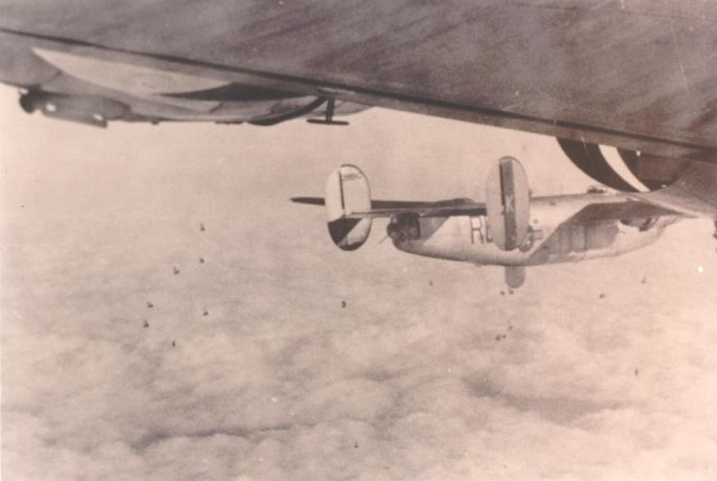
High-altitude bombing mission with radar.
Ground completely covered by clouds.
* Note the flak bursts below the planes.

The targets were located at Liege, Belgium. Magness, a buddy flight engineer who flew on another crew, was wounded during the mission, but not really seriously. We didn’t see any fighters, but the flak was very rough and accurate. We flew at high altitude for this mission, somewhere around 25,000 – 30,000 feet altitude. Flying time for this mission was four hours and twenty minutes. During missions number seven and eight, we had fighter escorts due to our flying well into enemy occupied territory. The escorts consisted of primarily P-47 Thunderbolts and P-51 Mustangs. On one of the missions we had some P-38 Lightnings.
Our eighth mission took us into Germany. On Monday September 11th, 1944, we took off to bomb a jet plane factory (primary target) and an oil refinery located one mile southeast of Magdeburg, Germany. Prior to using radar to identify the target, we often had secondary targets to bomb in the event the primary target was unattainable either due to weather or miscalculation. Magdeburg was our target because the Germans were developing a jet fighter plane there. If they'd been successful, the outcome of the war may very well have been different. None of the aircraft that the Allies had would have been able to catch a jet fighter, let alone engage one in a dogfight. We didn't encounter any fighters during the mission, but the flak was the heaviest we had ever seen. The lead plane was shot down, and ten men were lost. We never heard if any of the crew made it out of the plane or whether it may have been fortunate enough to make a crash landing. Again, we flew at high altitude and flying time for that mission was six hours and thirty-five minutes.

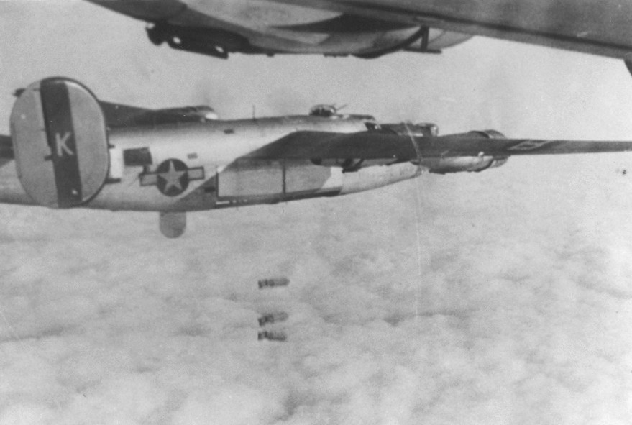
High-altitude bombing

Our crew then did not fly for seven days. A break this long was sometimes due to poor weather conditions. On Sunday morning September 17th, 1944, the duty sergeant came to our barrack to inform me that I was needed at the briefing room immediately. I went to the flight line and was informed that I was to fly with Larry Hewin's crew on a practice flight as an engineer because their engineer had been in a bicycle accident the day before and broke his arm and therefore could not fly. The practice flight was at a low level all the time. We were flying the Baggy Maggy [serial number 42-100416] rumored to have been named after the way the original pilot’s daughter dressed. Larry Hewin was the pilot and on this day we flew with only a partial crew. During the practice run we flew just over the trees, then back down below the tree line, then up over them and back down again. The tail gunner was in his turret for some of the flight, and he said we had twigs sticking out of the turret and leaves stuck in the wheel wells. The pilot had fun, but most of us didn’t like the flight. It was too low. After the training flight, I was told that I would be flying in the mission the following day with Hewin’s crew.

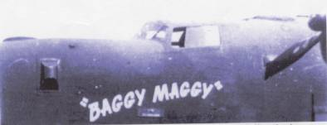
The Baggy Maggy

This I did not like. On our initial flight to England, the entire crew (Digman's Crew) had vowed that we would not fly with other crews just to get our missions in and go home. Typically after completing twenty-five missions, you were eligible to receive a leave of absence to go statewide for a period of time. It wasn't uncommon for flight personnel to volunteer to fly in as many missions as they could in order to reach their twenty-fifth mission and get a leave home. Contrary to this, our crew wanted to all fly together and to all go home together when we made our twenty-five missions.
I went to see my pilot Joe Digman about the mission, and he talked to Major Brown, our squadron commander. Major Brown said I had to fly with Hewin's crew, because Digman's crew was not flying that mission, and I was the only other engineer available. The next morning, at the briefing, they told us it would be a low-level mission, flying in supplies (fuel, ammunition, food, etc.) to the largest paratrooper landing of the war. This offensive was taking place in Holland, and was called Operation Market Garden.
Operation Market Garden was to be the liberation of Holland and the drive needed to end the war by Christmas. Market was the airborne element of the offensive and Garden was the ground force. It was the largest airborne operation ever mounted. Thirty-five thousand troops would fly three hundred miles in troop-carrying planes and tow gliders, then be dropped sixty-four miles behind enemy lines in Arnhem, Holland. General Patton and General Montgomery's armor divisions were closing in on the Belgium border. Paratroopers from the British 1st Airborne Division and Polish Brigade, coupled with the American Army 82nd and 101st Airborne Divisions were to be dropped behind enemy lines and seize control of the bridges, so that the Germans couldn't destroy them as the Allied Tank Corps arrived. The book and movie A Bridge Too Far was based upon this offensive.

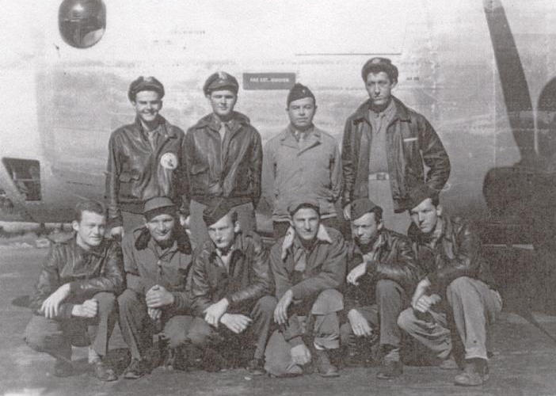
The original Larry Hewin Crew
Back row, from the left: George Sadler, bombardier; Will Landon, navigator; Richard Scott, copilot; Larry Hewin, pilot.
Front row, from the left: Stuart Burford, right waist gunner; Eugene Shabatura, left waist gunner; Frank Walton, engineer; Bill Kirlin, radio operator; Ozzie Malone, tail gunner; Joe Stalling, nose gunner.

On Monday September 18th, 1944, I embarked on my ninth mission and what would be the last flight of the Baggy Maggy (and the Hewin Crew). Other than knowing that Larry Hewin was the crew’s pilot, I didn’t know any of the crew members prior to this mission. Three of the original crew members did not fly that day. They were Frank Walton, Will Landon, and Joe Stalling. Frank Walton was still unable to fly due to his injuries. Will Landon was attending advanced navigator training. Joe Stalling was initially scheduled to fly as the nose gunner; however, due to the mission not requiring a bombardier, George Sadler volunteered to take over the nose gunner position. This allowed Stalling to be absent from the mission. Replacing the three original crews members were; Henry Greenberg, navigator; James Bolton, supply specialist, and myself as the engineer.
Our target was a several acre field located southeast of Arnhem in Groesbeek, Holland. This is where we were to drop the supplies for the paratroops. At the briefing they told us it was to be a milk run, and we probably would not get credit for the mission. I don’t know what made me go back to my locker at the flight line. This is where we kept our flying suits and other things such as our dog tags and my .45 pistol. I got my .45 and put it in my shoulder holster and put my dog tags around my neck. I had on my summer flying suit, my G. I. shoes, and a medium weight bomber jacket.
Throughout the morning and early afternoon hours, the mission was initiated then halted numerous times due to coordination problems between the ground units and the air units. We just waited and waited. Finally, some time around 2:00 p.m. or 3:00 p.m. we took off. It was a low-level flight all the way to Holland. In fact, at one point the tail gunner called across the intercom that his feet were getting wet as we crossed the English Channel. This was called "prop wash." We were flying so close to the water that the wind coming off the engine's propellers was spraying the water back onto the tail turret. We flew this close to the water in order to keep below the German radar. When we finally reached the coast of Holland, the pilot had to pull the plane up and ascend briefly in order to clear the treetops. The Hollanders planted their fields in squares and had hedges planted on all four sides of the fields. We flew up over the hedges then back down again and hugged the fields until the next hedgerow. We continued flying at an altitude of approximately two hundred feet until we neared the drop area. Once we reached the drop area, we were to climb to six hundred feet and drop the supplies.

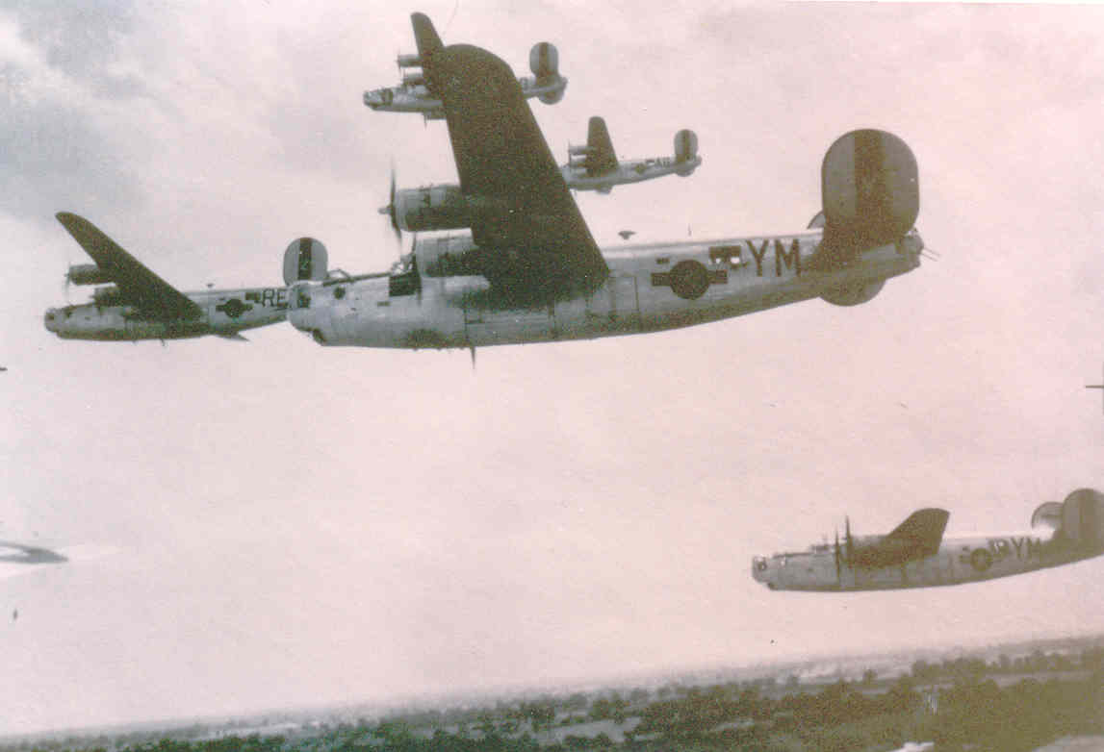
En route to drop area

As we were approaching the drop area (Arnhem, Holland) we were picking up ground fire consisting of both small arms and machine gun fire. The Germans were firing everything from pistols and rifles to handheld machine guns. All of a sudden there was an explosion on the front left side of the bomber, in front of the control panel at the pilot's feet. I was in the top turret when the explosion occurred. It didn't take me long to get out of the turret. Once clear of the turret, I helped the radio operator get the pilot out of his seat and back to the flight deck so we could work on him. The exploding shell (thought to be a 20mm round) sent fragments of metal from the pilot's waist to his toes, hitting several arteries as well. We gave the pilot a shot of morphine and applied tourniquets on his legs to stop the bleeding. The exploding shell also took out a lot of the plane's controls. The copilot got the bombardier to sit in the pilot’s seat and help control the plane by working the rudder pedals with him. The hydraulic system (which works the brakes, landing gear, bomb bay doors, and flaps) was shot out. The plane's intercom also went out, severing communication among the crew.
Another crew flying with us that day saw us going down, but basically we were on our own. The radio operator and I were busy aiding the pilot, and in those days there was no radioing in that you were going down. There’d be no search and rescue plane dispatched. Our only chance of avoiding enemy capture was to make it to allied held territory or get assistance from the Dutch underground.

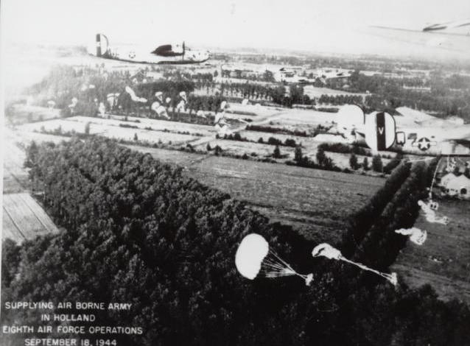
Drop area over Arnhem, Holland

We jettisoned our supplies and tried to get out of there. All four engines were running in the red because the oil lines had been hit, too, which meant the engines could stop at any time and seize up due to overheating. Our airspeed was now only approximately 150 m.p.h., as this was as fast as the engines would go at this point. Coincidentally, takeoff speed for a B-24 was approximately 160 m.p.h., cruising speed was approximately 170 – 180 m.p.h., and maximum airspeed was close to 290 m.p.h. Landing speed was approximately 150 m.p.h. in order to still have enough control over the airplane to navigate a safe landing. Running with engines in the red, and seeing that we couldn’t climb any higher, the copilot decided to crash land if he could find a field long enough for us to land in. We headed for the Belgium border. Although Belgium was still occupied by the Germans, Patton's tank division was there, too. Knowing if we survived the crash, maybe we’d have a chance at making it to the American troops.
As the copilot fought to control the ship, the radio operator continued to work on the pilot who was now lying on the flight deck behind the pilot's seat. Since we had no intercom, I went back through the bomb bay to let the rest of the crew who were in the waist and tail sections know that we were going to crash land and for them to take their crash positions. I then had to go back through the bomb bay again to get back to the flight deck. There is only a six-inch “catwalk,” and you can’t wear your parachute when you go through the bomb bay because the walkway is so narrow. The bomb bay doors were wide open, and we were only two hundred feet off the ground. The Germans were shooting any and every thing they had at us as we flew by. I could actually see German soldiers pointing their guns and firing right at me. This didn’t give me a very pleasant feeling as I went through the bomb bay, especially if a stray tracer bullet would have happened to come through the bomb bay and hit one of our gas tanks that were located within the wings. Boom! Nothing would have been left of us. As I walked through the catwalk, I recall seeing that our load of supplies had in fact been jettisoned. We surely didn’t want to just hand it over to the Germans.
I eventually made it back to the flight deck just as we were making the landing. I was able to assume a crash position behind the co-pilot's seat next to what was called the coffin. The coffin was the protective armor plating (often ¼ inch thick steal plating) surrounding the pilot and copilot’s seats, thus forming a “coffin” to theoretically shroud and protect them from flak and gunfire. At approximately 4:00 p.m., about ten minutes after being shot, we crashed. When we hit the ground the plane broke into three sections. The tail section was first, then the waist and bomb bay section, and finally the flight deck and front end of the plane. We crashed landed into a farmer’s potato field southeast of the small village of Castelre, in the territory of Baarle, Holland. I guess when we hit the ground we were knocked senseless, because I had a feeling of floating in the air or that I was in another world. I think we all went through those same feelings, judging by the other's reactions and the way each of the crew members related their feelings of the crash. It took several minutes until we started to move around and realized that we had survived the crash. The pilot, as badly wounded as he was, and having just received a shot of morphine before we crashed, crawled out of the wreckage and ran almost a hundred feet before collapsing along side of the dirt road where the front end of the plane came to a halt. The copilot and bombardier were upside down in their seats, and they could not loosen their safety belts. I had a pocketknife with me, and I cut the seatbelts so they could get out. The copilot was wounded in the head by shrapnel. Fortunately the bombardier, navigator and I were not seriously wounded and were able to walk out of the crash. Several other members of the crew had been wounded by the ground fire or injured as result of the impact of the crash.
I noticed we had a small fire in the right inboard engine. The navigator and I burned our maps and other sensitive information we were carrying. We then put the fire out because the radio operator was still trapped in the plane. Prior to the crash he had been rendering aid to the injured pilot, which placed him immediately below the top gun turret. Upon crashing, the top turret, weighing close to eight hundred pounds, had broken loose and crushed him to the side of the fuselage. We couldn’t move the turret or tear the fuselage away from him. I lost my .45 caliber pistol during the crash, and we weren't carrying any ammunition on board for the gun turrets. Thus we were pretty much defenseless. We had been concerned with the weight of the added ammunition, and besides, this was supposed to be just another "milk run."
By this time we were all more or less out of the shock of the crash and were checking our wounds and injuries. The Germans made their grand appearance and told us the war was over for us, the war was "kaput." The situation got a little more tense when the Germans saw that I was wearing an empty shoulder holster. They thought I hid the pistol, but I had no idea where it was. They did take my watch and boot knife. They allowed me to keep my wedding ring and later they gave me my watch back. Before we left the crash site, the Germans told us that Bill Kirlin, the radio operator, was dead. The Germans took what they wanted from the plane, then with Kirlin's body still inside, they set the plane on fire. The plane was later salvaged then scrapped. By the hands and the skill of Lieutenant Richard C. Scott, Sr. nine men out of ten survived the crash of the Baggy Maggy.

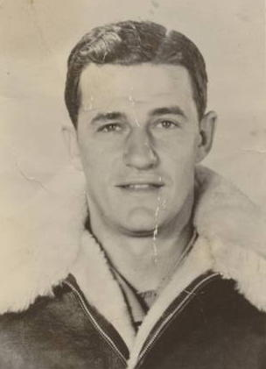
T/Sgt. William Kirlin, K.I.A.

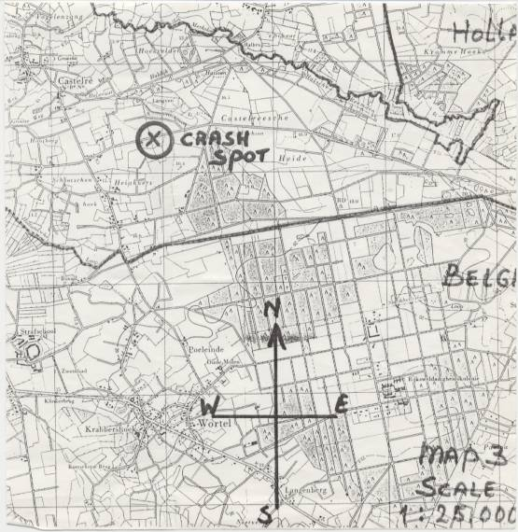
Crash site in Holland, just north of the Belgium border.

The crash site was south east of Castelre, Holland. At this point in the war, this was German-occupied territory. We almost made it to Belgium. The border was a very short distance away, perhaps no more than a mile. Army Intelligence later showed that there were more German Troops in the area where the Market Garden Offensive took place than what they had expected would be. In fact, a significant number of the paratroopers were killed or captured as Prisoners Of War (POWs) due to landing right smack in the middle of a German SS Panzer division. General Patton's and General Montgomery's armored divisions (tank corps) eventually liberated Holland in late 1944.

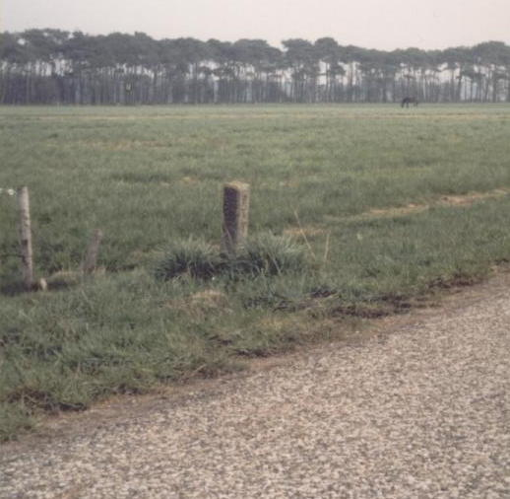
Crash site marker

The Germans forced a local Dutch farmer, who had been in the area taking up potatoes, to take us in his wagon into a town near where we crashed. We were put into the farmer's wagon and taken to Ulicoten, a nearby town still in Holland. There the wounded men were turned over to a medical unit, and the rest of us were put in the basement of a house the Germans commandeered. Not long after we were put into the basement, a couple local boys came to the basement window and gave us apples to eat.
The morning of September 19th, 1944, the German guards took Lt. Henry Greenberg and me out of the house. We were not as seriously wounded as the other members of the crew were, therefore the Germans marched us several blocks to where there was a big tractor and trailer awaiting. There the Germans were loading other prisoners of war, U.S. paratroopers, and other Army personnel into the trailer. The trailer was a flat bed trailer with sides approximately five feet tall. We were hauled to a railroad station a couple of hours away. I believe the station was in Germany. Once at the railroad station, we were then loaded into "Forty & Eight" boxcars. These were railroad boxcars from World War I which could carry forty men and eight horses, hence the name "Forty & Eight." However, there were much more than forty men being packed into these box- cars. With standing room only, the train headed deep into Germany.
While en route, some POWs were fortunate to get a little sleep by lying down on the wood floor of the cars as others stood crowded tightly together. We'd then rotate and allow some others a chance to get a couple of hours of sleep. You were fortunate if your box car had a bucket in it. That was our latrine! I was still wearing my summer flight suit (coveralls), GI boots, and lined cloth bomber jacket. The Germans took my shoulder holster. I was kept in the box car until we arrived in Germany several days later. During the train ride we were not fed, nor were we given any water.
The train headed for the interrogation center at Dulag Luft, near Frankfurt on the Rhein River in Germany. This was where all airmen were interrogated by the Germans. We finally arrived after several days. I was kept at the interrogation center for three days. It was there that I was separated from Lt. Greenberg.
During the interrogation I was taken before a German Officer who could speak perfect English. It was apparent that prior to the war he either lived in or attended college in the United States. As a prisoner of war, all I needed to tell them was my name, rank, and my serial number. The German interrogator was telling me where he had been in the States before the war. He then would ask me questions like, "Where in England were you stationed…how many bombers did you have there, etc." After I did not answer any of the questions he asked, he started naming my crew members names. "Digman, Holbrook, etc." naming the entire crew. He then wanted to know where they were. Through their spies and intelligence units, the Germans had information about my regular crew, but not the ones I flew with the day we were shot down. The interrogator got very angry when I wouldn’t tell him anything about the crew. He then ordered me into solitary confinement for two days.
Solitary confinement was a room about the size of a small closet, which was not big enough to lie down in, had no windows, no toilet, and only had a washbowl. The faucet in the room was rigged so that you couldn't stop the water from coming out of it. The water dripped all the time I was there. Two days later they took me out and a different interrogator tried to make me talk. Nothing doing, only name, rank, and serial number were all they got. This infuriated the interrogator even more, and he struck me with a one-inch thick rubber hose. As a result, I was bruised on my back and shoulders.
Other than some soup at the interrogation center, I still did not get any significant food since being shot down. That was seven days earlier.

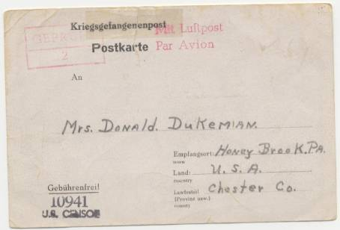
POW notification post card. The post card was
sent to my wife after my interrogation at Dulag Luft.

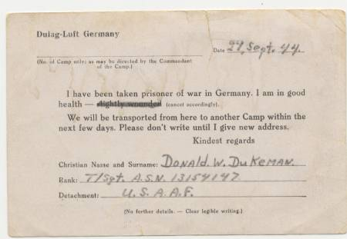
Side #2 of POW notification post card

Upon leaving the interrogation center, I met up with Lt. Greenberg again. We were put back into a box car, again packed so tight there was standing room only, and we headed for a POW camp for airmen. The trip was by a roundabout way, with a stopover at the Nurenburg concentration camp. The Germans kept us there overnight. The camp was empty besides us, but I saw what had been occurring there. I saw the gas chambers, the graves, and piles of human bones lying stacked in a field. This was very rough on all of us, especially Lt. Greenberg, who was Jewish. The Germans also knew which of the POWs were Jewish. We were then forced to spend the night in the barracks where the Jews had been kept. I was sure this visit was another means for the Germans to intimidate us. It was as if they were "showing off" the camp and its horrors. One has to remember that there was not much common knowledge of concentration camps in 1944. I only had heard of them based upon what limited information was given during mission briefings.
The next morning they put us back into the box cars and we headed for Stalag Luft IV, located just outside of the town of Grosstychow, in East Pomerania. This took us across Germany, up almost to the Baltic Sea. During the entire trip through Germany we traveled a lot at night so we would not be strafed (machine gunned) or bombed by Allied aircraft. However we were still bombed several times by the British at night. We were really lucky when we got to Berlin. It seemed like there was an all out raid on the railroad yards that night by the British bombers. We were sure we would not make it out of Berlin, but God was watching over us and we made it out all right. The bombing shook the ground around us, with debris and shrapnel hitting the box cars. Luckily no one was hurt on our train.
Berlin was where Lt. Greenberg and I finally parted. All officers were sent to Stalag Luft I, at Barth on the Baltic Sea. The enlisted men were sent to Stalag Luft IV. We finally arrived at the railroad station at Kiefheide, Germany. There we were unloaded from the box cars and roped together. The Germans then made us run to the camp, which was almost two miles away. During this run the German guards had their bayonets fixed on their rifles, and they had police K-9 dogs running along side of us. If someone fell they would either stab us or put the dogs on us. If a soldier fell you either picked him up and carried him with you or you went down with him and suffered the same fate by the dogs or bayonets. The "run" was done to show us we were in fact prisoners, and with the expectation that some wouldn't make it. Some didn't. Some soldiers died that day as well as every day that a group of prisoners were sent to Luft IV.
I finally arrived at Stalag Luft IV on October 7th, 1944. The location was where the meridians crossed the globe at 54 degrees latitude and 16 degrees longitude, in the Pomerania sector of Northern Germany, near the town of Grosstychow and the Railroad Station at Kiefheide, very near the Baltic Sea.

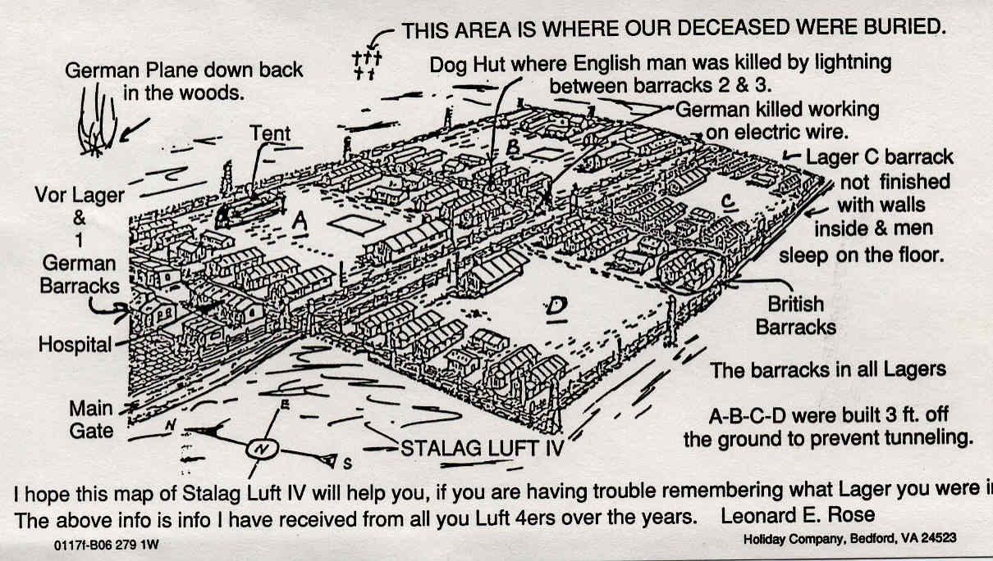
Stalag Luft IV

I was assigned a prisoner number. My number was 3692, which was stamped into a metal plate which I still have. The tag was put around my neck with my dog tags. I had to wear it the entire time. I was assigned to Lager B, barracks #10, room #12. A lager was a sort of sub-camp within the overall Stalag. Each lager housed approximately two thousand men. There were four lagers in camp, A, B, C, and D. There were ten barracks to a lager, twelve rooms in each barrack; ten of the rooms housed twenty-four prisoners each, with one additional room for a pit toilet for night use and one room used as a wash room. The washroom had merely a metal trough used for washing. There was a hand pump in the middle of each barrack, which was where we drew our water. As soon as I arrived in camp I was given a shower. I only had one other shower during my entire imprisonment at the camp. By going to get a shower, one had to wonder if he was going to be gassed as the Germans done at the concentration camps. Just prior to being shot down, I had read about Jews being led out of camp under the guise of getting a shower and wound up getting gassed. Fortunately, I was led out of the compound to a nearby building which actually did contain showers.
In each assigned room there were twelve bunk beds, single width. We slept on elongated paper sacks filled with wood shavings, which after sleeping on them felt like sleeping on wallboard. The bottom of the beds had six wood slates across them. Some of us were lucky and had two wool blankets, others only had one. We had small stoves in each of the rooms which burned small coal briquettes. When we could get them was far and few between because of the coal rations imposed on each room. We were colder more often than we were warm the whole stay at Luft IV. The only thing good for us was that we did finally get something to eat, even though it wasn’t much. My first meal in nineteen days consisted of cabbage soup, saw-dust bread, and some potatoes.

This is the list of the men in my room. Although it appears we were grouped alphabetically, I do not believe that was the case.

Stalag Luft IV, Lager B, Barrack 10, Room 12

Rank Name Army Serial Number P.O.W. Number

S/Sgt. Buschmeir, F.W. 35683437 3121
S/Sgt. Capps, R.J. 39209735 3677
Sgt. Christy, J.D. 35419667 3675
S/Sgt. Cochran, R.L. 33682763 3678
S/Sgt. Conner, L.E. 14109323 3679
S/Sgt. Cook, C.C. 35281764 3680
Sgt. Cook, S.W. 16187601 3681
Sgt. Coombs, C.T. 37677357 3682
S/Sgt. Costa, J.J. 12205557 3683
S/Sgt. Cotton, R.E. 37260655 3684
Sgt. Culbertson, J.K. 39332991 3685
S/Sgt. Cummins, F.E. 35583735 3686
Sgt. Dallas, J.R. 6580032 3687
S/Sgt. Denter, J.J. 32856371 3688
S/Sgt. Dingler, F.H. 14129399 3689
Sgt. Downing, R. 37522454 3690
Sgt. Dryer, A.W. 38458896 3691
T/Sgt. Dukeman, D.W. 13154147 3692
S/Sgt. Eickemeyer, H.H. 37454581 3693
S/Sgt. Engleman, J.J. 12170349 3694
T/Sgt. Furbish, A.I. 39561357 3371
T/Sgt. Greene, H.W. 33524758 4798
S/Sgt. Long, W.P. 19122845 4998
T/Sgt. Luzzi, S.L. 11080127 4999

The lagers were rectangular in shape with five barracks on each of the longer sides. There was one outside latrine, a washhouse in the center of the compound, and a water pump located in the middle of each row of barracks. One end of the lager had a larger building which served as a kitchen. It also contained two offices, two sleeping rooms (for the cooks and POW "Compound Leaders"), and a larger room known as the "Red Cross Room." Each lager also had its own guard towers with machine gun nests and search lights, sirens, and K-9 dogs (German shepherds). The barracks in Lager A were built on the ground, but the other lagers’ barracks were built above the ground (at least three feet) so that the prisoners were less likely to try and dig a tunnel below the barracks.
The lager had two nine-foot high barbed wire fences running parallel, about three to four feet apart, around the entire perimeter. On top of each fence was rolled barbwire. There was another single strand of wire, about four feet in front of the two main fences, which ran about knee high. We had to stay inside this single strand of wire. If we got between the low wire and the tall fencing, we would be shot. Both of the tall barbed wire fences were electrified and would kill you outright if you touched any part of them. We saw several prisoners take their own lives by crossing the low wire. They did not stop when the guards ordered them to stop, and they were killed. Two men were also electrocuted when they touched the wires.
Each lager of the camp was laid out this way. The lagers were each independent of the camp. The prisoners did not leave a particular lager unless they were ordered to do so by the guards. This may have been to take a shower or to get deloused. After my initial shower upon arrival at camp, I was permitted one additional shower and one delousing during my entire time there.
The camp was built close to a forest, so we asked the German guards if we could go out and cut wood to keep warm when we didn’t have coal. We were told "no" because we were considered Noncoms, short for non-commissioned officers (ranks of corporal through sergeant), and under the Geneva Convention we could not do any work as prisoners of war. This also meant we couldn't work even if it would have helped us to endure the horrors of being prisoners of war.
The camp was located approximately ten miles south of the Baltic Sea. Often the days and nights were a bitter "wet cold." There was also a lot of frostbite. Back at the interrogation center, my clothes were taken from me. I then was given back my own flight jacket (which was the lighter summer issue style), but another's G.I. shirt and a pair of British pants and British boots. This was the only clothing I had.
The day's menu was no breakfast, and dinner (lunch) was barley soup or some other tasteless broth watered down to go further. Supper would be plain boiled potatoes and a quarter loaf of black saw-dust bread, (yes three quarters of the bread was actual saw-dust with a little flour in order to make it stick together and it looked like bread). It was a very heavy and solid bread that wouldn't rise. It tasted bland, just like a pile of saw dust. This bread had to last us a week. Sometimes they would substitute cabbage soup, or stewed greens, and less often we would get several small pieces of red stringy horsemeat for supper. The Red Cross food parcels we actually received at the camp, and while we were on the Death March, were what saved most of our lives.

Typical Red Cross Food Parcel Contents

1-can milk (16 oz. powdered milk) 1-jam (6 oz.)
1-margarine (16 oz.) 1-cheese (8 oz.)
1-box biscuits (6 oz.) 1-tuna or salmon (8 oz.)
1-box raisins or prunes (16 oz.) 1-coffee (2 or 4 oz.)
1-box sugar 2-soap bars
1-Spam (12 oz.) 1-cocoa (8 oz.)
1-corn beef (12 oz.) 1-peanutbutter (6 oz.)*
1-liver pate (6 oz.) 1-roast beef (8 oz.)*
2-chocolate bars (4 oz.) 5-packs cigarettes
1-meat and beans (8 oz.) 1-meat and vegetables (8 oz.)

* Rare items.

# 2 Invalid Food Parcel

1-can milk (16 oz. powdered milk) 1-box sugar (8 oz.)
3-preserved butter (9 oz.) 3-pork loaves (9 oz.)
5-pea soup mix 6-7 packs cigarettes
8-bouillon mix 2-soap bars
3-bacon and eggs (9 oz.) 1-raisin or prunes (16 oz.)
1-cocoa mix (8oz.) 1-tuna or salmon (8 oz.)
1-jam (6 oz.) 1-biscuits (6 oz.)
1-cheese (8 oz.)

Typically a parcel of food was shared among four to five men. We kept the food in our rooms. We would sometimes trade the guards chocolate, or soap, or cigarettes out of the parcels for extra food or extra coal to try and keep us warm in our rooms.
We had two roll calls a day, one every morning and one every night, before we were locked in the barracks for the night. We never knew when, but the Germans would search our rooms at any time, at night also. They would make us stand out in the hall while they would tear our rooms apart looking for a radio, or to see if we may be trying to make a tunnel to escape out of the camp. Some of the searches last for a couple of hours.
Having a radio meant we could get news in camp. Each camp usually had at least one makeshift radio. We'd listen to the BBC (British Broadcast Communications) each day, and the news would be passed around camp. The guards usually didn't find the radios. The radios were valuable because the Germans would tell us one thing, then we'd hear on the radio something different. Examples of this would be who was winning a particular battle or offensive and what target was recently bombed. Even more of value was how close were the Allied Troops to the liberating the camp.
There was no heat in the barracks, except what we may have in some of our rooms if we had any coal. We could almost freeze in the halls during the winter because it took them such a long time to search every room. The barracks were locked down each night before dark. No one was permitted outside of their barrack after dark. If so, the guards would interpret it as an escape attempt and you'd be shot. The Germans also put spies into the camp to gather intelligence. Sometimes they were effective, but any newcomers into the camp were well screened by the Camp Leaders to see if they were legitimate POWs.
The roll calls were something. Each lager had over two thousand prisoners in them, and if the Germans could not count right we may stand all day until the count came out right. We didn’t help matters any. We would foul them up as much as we could. They had to have us in rows of five deep. That was the only way they could count such a mass of men. They would always be in front of the lines, so after they had counted a few rows, some of the ones in the back row would sneak down to the end and stand there making the count turn out to be a lot more. The guards would then have to start all over again. We were always told to make as much trouble for them if we became POWs. We could have been shot, but after a while we knew about how long we could cause trouble before getting harmed by the guards.
We were not always watched by the same guards. The German foot soldier or "Wehrmacht" were the regular guards. They were often the older soldiers, and they treated us all right. When these "regular" guards were given leave, other German military units would furnish temporary guards. The Luftwaffe, which was the German Air Force, treated us O.K. When we had S.S. guards in camp, we would walk a straight and narrow line while they were there. They shot first then asked questions afterwards. Hitler’s Youth were just as bad as the S.S.
We had very little to do to pass our time away. We didn’t have much sporting equipment. We only had a very small collection of books to read, a couple of music instruments, and playing cards. The musical instruments were given by the Red Cross, and were kept in a designated room, not in the barracks. In good weather we walked around our lager to try and keep ourselves in some sort of physical shape. This also gave us something to do. There were a lot of card games played; poker, rummy, bridge, and solitaire. There were also checkerboards, and several chessboards. We'd hold tournaments as well. With over two thousand POWs in each lager, and four lagers totaling over eight thousand (sometimes reaching more like ten thousand) POWs in the whole camp, there just wasn’t enough of anything for everyone to do. We were allowed to mail three postcards and two letters each month to our families or loved ones.

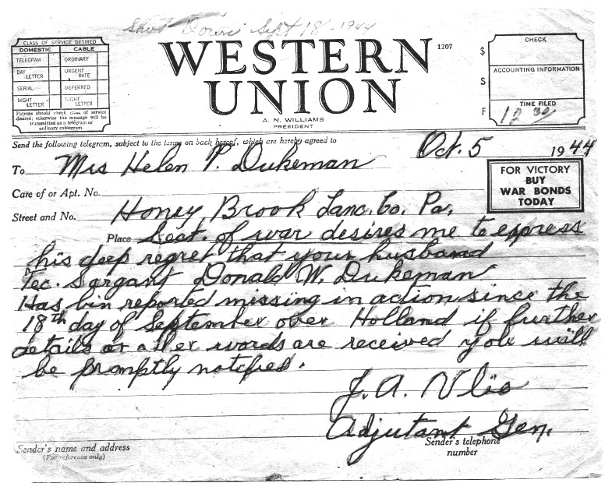
Telegram to Pauline advising her I was missing in action.

On October 5th, 1944, my wife Pauline received a telegram telling her that I was missing in action over Holland. She later told me she’d heard of so many men being reported as missing in action; however, she didn’t expect it would happen to me so soon. I had only arrived overseas a little over two months before being shot down. Pauline said she always felt I was alive and she knew deep down that I would come home. In order to help cope with the tragic news, Pauline kept busy working at the silk mill in New Holland. There she worked five days a week, sometimes more, making silk material for parachutes for the war department.

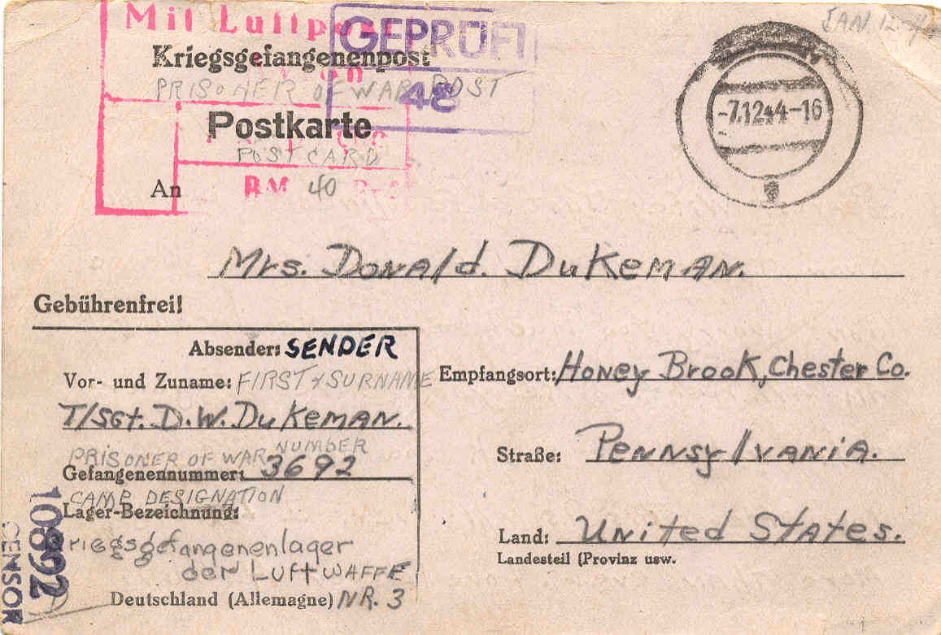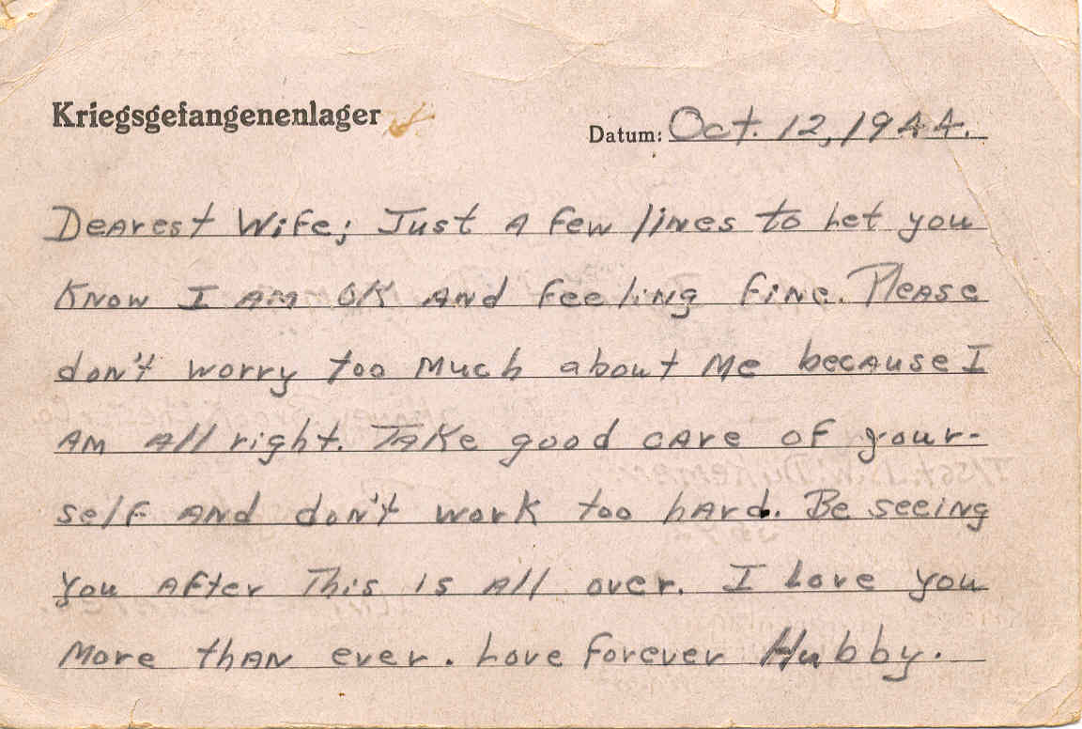
Post card I sent to Pauline from within Stalag Luft IV.

November 10th, 1944, was a very bad month for me. I turned twenty-one in a prisoner of war camp. Imagine spending a birthday behind barbed wire and gun towers. Imagine spending it as a prisoner of war.
My wife received another telegram on November 20th, 1944, stating I was a prisoner of war in Germany. The Germans notified the Red Cross that I was a prisoner of war. The Red Cross in turn notified the representatives of the Geneva Convention, who notified the U.S. Army, who notified our families.

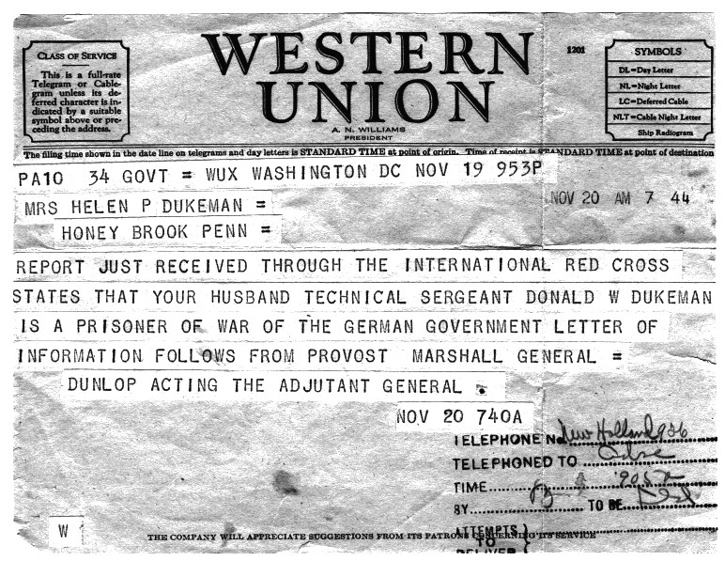
Telegram to Pauline advising her I was a POW.

Just after Thanksgiving of that year (November 25th, 1944), Pauline received a letter from the assistant director, Prisoner of War Division, U.S. Army, notifying her of my address and information on how to send mail and parcels to me in the prisoner of war camp in Germany. Our families were allowed to send one food parcel and two tobacco parcels every sixty days.
December of 1944 was no help to our spirits because Christmas was coming. This was no place to spend it, but we had no other choice. The most popular song for us was, "I’ll be home for Christmas, if only in my dreams." Even today at seventy-eight, I still get tears when I hear or sing this song, at any time, not only at Christmas. Fifty-seven years is a long time, but the memories we carry with us last a lifetime, some good and some bad.
The first and only mail I received were five letters. One letter was from my mother, and four were from my wife, and that was in January 1945. I never received any parcel from home. When I got home Pauline told me she had sent me a parcel every time she could send something. She was permitted to send one every sixty days. She said she sent me food, cigarettes, etc., but none of it ever reached me.
In the beginning of January, we had news reports that the Russians were getting closer and that the Germans were getting ready to pull us out of the camp so the Russians couldn’t free us. The report was that they were going to take us to the U. S. front lines and turn us over to our troops. This never happened. As the month continued we began to hear gunfire coming from the east, and that was where the Russians were coming from.
During that first couple of days in February, the most sick and disabled POWs were evacuated from camp. A couple of the lagers were evacuated as well. On the evening of February 5th, 1945, the Germans told us to be ready to march out of camp the next morning. We were told we would only be marching for two or three days. That night it snowed two inches or more. At around 11:00 a.m. on February 6th, 1945, the last two remaining lagers were evacuated and I began the march.
Since we were told we would only be out three days at the most, we did not take all the food we had. The guards gave each man one Red Cross food parcel as we went out of the gate. In two days there were ten thousand POWs evacuated out of Stalag Luft IV. Most of us were in groups of not over two hundred men. We had a ratio of one guard to three POWs. This one guard to three POWs did not last over two weeks because the guards whom we left camp with were all old men, and they could not keep up the marching day after day. Our three-day march turned into eighty-six days and close to a thousand miles with a climate that would be similar to that of northern to middle Canada during the winter months.

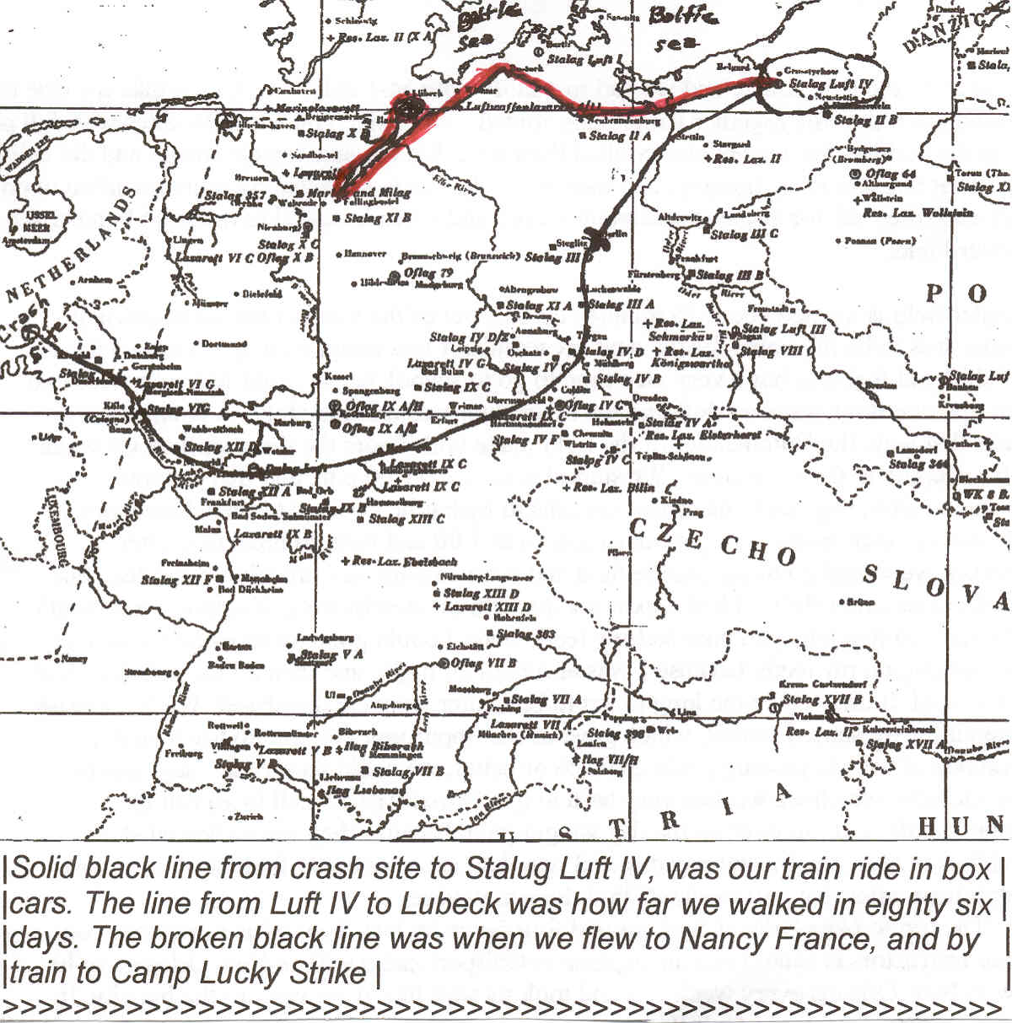
Route from crash site to Stalag Luft IV (lower route)
Black death starvation march (upper route)

We headed northwest while others headed southwest, and some even headed south. There were one hundred and five POWs in the group I was in. The first night out we slept under the stars on the snow in a pine forest. After scraping some of the snow away we used pine needles to sleep on. It was softer than the bunks at the camp that we left, but was still bitter cold. Most of us did not have fitting clothes or a blanket to cover up with. I had a shirt, pants, pair of boots and my bomber jacket. It snowed the entire first week of the march.
We often took back country dirt roads by day, and slept in open fields without any shelter at night. On occasion, we’d come upon a farm just before nightfall and if we were lucky, our guards would talk the farmer into letting us sleep in their barns on the straw or haymow. The farmers were very leery of letting us in their barns for fear we might set them a fire, or contaminate their crops or animals with something we might be carrying. We were not a very impressive-looking group of people: dirty, unshaven, sickly, lice-infected and starving.
Our diet, after three or four days out of Stalag Luft IV, began to be a problem. The Germans had told us we would only be on the road for three days. When we got the Red Cross parcel as we left camp, we picked over it and only took the lighter foods with us. It was not very easy for us to carry a twelve or fifteen pound box on the march. Most of us were out of food by the fourth day. From that day on we only had what we could beg, borrow, or steal. We often got our drinking water out of a creek. Somewhere along the way we stopped by a creek to take a ten-minute break. Well, a lot of us crawled into the creek and nearly got shot for doing so.
We were lucky sometimes when we got to stay at a barn, because often there were things we could beg or steal from the farmers. At a lot of the farms we stayed at the guards would get us potatoes. Sometimes the German farmers would boil them with the skins on for us. Once in a while we would get some saw-dust bread too. We carried those potatoes for days, because that was all we would have maybe for days on end. We slept in open fields and woods more than in farmers' buildings. During those times we didn’t have anything to eat other than the potatoes we carried with us. Along the way I fashioned a cup out of a food can. I punched a hole in it and tied a string to it. Thus, if the opportunity presented itself, I could at least get a drink of water.
As we could, we took chickens, rabbits, sugar beets, greens, and kohlrabi (cabbage-like vegetable). We even milked cows if we could get away with it. Also at times, we took anything that moved and was edible. The Germans didn’t have too much to eat either because the military took the food they had for the Army. Our guards would try to get food when we stayed at farms, but they went hungry sometimes, too. A person who wasn’t a POW would never believe what we went through or what we might have eaten to keep alive. We often wonder how the ones who survived did make it home. Several thousand POWs didn’t.
We had another worry beside having no food. When we marched through the larger towns the guards would let the people know ahead of time that they were bringing in American POWs from the Air Force, as we were the ones who bombed the cities. Most of the people would scream, “Murderers…killers!” and they would throw stones, rocks, and anything they could get their hands on at us. Some even took pitchforks and clubs to us. The guards couldn't, or should I say wouldn't, protect us. Fortunately, no one in our group was ever really hurt seriously, but we did have some that needed first aid. Another concern was that, even if we needed it, we didn’t have any first aid supplies with us on the march.
Approximately two weeks into the march I lost the movement of my right arm. I couldn’t even hold anything in my right hand. I don’t know why this happened, and fortunately after a couple of days it cleared up and I regained use of my arm.
We were on the road thus far for fifty-three days, when we reached Stalag Luft XI B at Fallingbostel, Germany on March 28th, 1945. This camp was made up of POWs from all countries; British, Canadians, Poles, Frenchmen, Russians, U.S., Australians, etc. We stayed in a very large tent (like a circus tent today). We had straw on the ground to soak up the dampness and mud, and serve as our beds at night. There may have been a hundred of us in one tent. It was for shelter from rain and snow by day and some place to sleep at nights. It was better than sleeping in the open fields and woods. I was able to get my boots resoled as they were wearing thin. The guards came around and inspected our boots, collecting the ones that needed to be resoled. They were given back to us after the repairs were made. The food there was very short because they brought in so many of us who were on the roads since leaving Luft IV and arriving into this camp. We were there until the 7th of April 1945, when they took us back on the road again. This time we headed north, crossing the Elbe River at the same bridge we crossed on the way to Luft XI B.
There was no method to the way the Germans marched us. No maps, just forced marches. We started out marching northwest, then turned and went south until we neared the Allied battle line. We were then forced to march back north towards the Russian front, then back south and finally back north again. All in all we crossed the Elbe River four times. As the war was nearing an end, these marches occurred throughout Germany. As the Allied armies closed in on the P.O.W. camps (concentration camps as well) the Germans were determined to not allow us to be liberated. Thus, as we neared one battle line, they changed direction and marched us away from the Allied troops. For the most part we marched across the backcountry, often on dirt or oiled stone roads. With freezing temperatures, inclement weather and lack of adequate food, clothing and shelter, multiplied by being forced to march mile after mile, day after day, many POWs died an agonizing death along the way. Those who could not keep up were often shot and killed. Hence, the march was called the infamous "Black Death Starvation March."
On April 19th, we received two Red Cross parcels per man. That was the most food parcel we received, per man, since we were captured. I ate three candy bars that evening and got deathly sick. We had received only two other parcels during the fifty-three days, and we shared a parcel between four men both times. The Red Cross knew of the march and tried as often as they could to get food parcels to us. However, a lot of time the Germans would not let them.
Hitler’s birthday was on April 20th, 1945. On that date we were strafed by four British Spits (Spitfire fighters), making three passes at us. Luckily no one was hit. The Spits didn't know we were POWs, as the Germans did not want this to be known, because they didn’t want the Allies to know where they were moving the POWs. A couple days after the 20th, our guards told us that Hitler had ordered all POWs be killed. The guards, however, knew the war was coming to an end, and that if we were killed they would have been killed for killing us. Again, our Heavenly Father was answering the prayers from home and looking after us to protect us.
On April 21st, 1945, we received another food parcel. One parcel to be divided among three men. Knowing the war couldn’t last much longer, we decided to try and keep the parcel for our liberation. On April 22nd, we traded cigarettes from the parcel we received for one quart of wine and one quart of gin in order to celebrate our liberation when it happened. The last ten days we spent at a farm on the outskirts of the city of Lubeck, Germany. The farmer there was very good to us. Perhaps out of sympathy towards us or maybe even more so out of fear as the war was ending. There were one hundred and five of us prisoners at this farm. About five miles away at another farm there were another one hundred more prisoners. All added together in a radius of twenty miles, and four farms, there were over five hundred prisoners.
The farmer let us paint "POW" letters on his barn roof. There were a lot of our planes flying in the area where we were, and we didn’t want to be killed by our own planes after going through what we went through for the last eighty-six days. The farmer killed some chickens and also a small pig. His wife baked us some bread and made some sweets. We ate the eggs and drank the milk. We were treated very kindly during our last ten days of being prisoners.
On the evening of May 1st, the guards told us we would be free in the morning. We didn’t exactly believe them, but we knew it wouldn’t be much longer. We could hear the battle going on to the south of us. The next morning the guards, of which there were only three of them now, gave our group leaders their rifles and became our prisoners. At 10:15 a.m. on May 2nd, 1945, six U.S. soldiers arrived in an armored car pulling up to the farm where we were. After eight months of being prisoners of the Germans, we were finally liberated!
We walked into the town and met the U.S. armored division coming through the town. The lead tank came to a halt when it saw us. The hatch flew open, and a major came scrambling out and jumped down to us. He hugged us and we all cried like a bunch of babies. This day I will never forget. He said he didn’t have any food there with him, but the food truck was the last truck in the line of tanks and we were to stop it and he would give us food. He told us to get anything that would run and head for Boizenburg, Germany, which was about twenty miles south of where we were. He also told us that everything south of us was now in U.S. hands, so we should not have any trouble getting there. Finally, he told us to get going, because the town had not surrendered yet. We found enough cars and truck to take us to Boizenburg.
Boizenburg was located on the Elbe River. This was where we crossed two times prior during our march across Germany. The Army Corps of Engineers now had charge of the town. Since the Germans had blown up all the bridges as our troops advanced, the engineers were first into town and had to rebuild the bridges so our armored divisions could cross the Elbe River and continue their advancement to Berlin.
We arrived in Boizenburg after supper had been served to the troops there. However, one of the head officers took all one hundred and five of us Ex-POW’s to the mess building and the cooks served us up a wonderful meal. The first real meal I had since I left the Air Base in England on September 18th, 1944. After the meal, the officer took us out to several large buildings and told us to make ourselves at home wherever we wanted to sleep that night. These buildings were apartments with all the furniture intact. Some even had food still left on the tables, because the Germans fled the area as our troops advanced on their town. It was a ghost town as far as seeing any Germans. We had beds to sleep on, sheets, blankets, and living room furniture, etc. We were in seventh heaven, bathrooms and all the pleasures of a home.
On May 3rd, 1945, we woke up still thinking we were dreaming, but it was real this time. We were free people! We really were free, because the engineers let us roam about town, doing what we wanted to do. We were not under the Army rule as of yet. When we went for breakfast we could have anything to eat. If the cooks had what we wanted, we got it. We had eggs done any way we wanted. We had meat if we wanted it and anything else. After breakfast the cooks gave each man a "Ten-in-One" ration. Each ration would normally feed ten men for one meal. We could have all of these rations we wanted. On the two following days, all one hundred and five men could have died because of the food we were eating. We all got very sick because our digestive systems were not used to these types and amounts of food. Thanks to the Medical Corps, and a couple doctors that were stationed with the engineers, we all survived. We did thereafter change our eating habits.
There was a large factory near where we were staying. We decided to inspect it and hunt for souvenirs. Some fellows took silver place settings from where we were staying and other things too. In the factory we found all kind of goodies to take. What was so funny was the people's lunch boxes were there and some still had food that was half eaten. That gave you a spooky feeling. We found a railroad car on a siding (a short length of track that opened onto the main track at both ends and was used for storing cars or trains being passed) that had crate after crate after crate of brand new German rifles. The rifles were military rifles similar to our M-1s. They still had the grease on them, so you know what happened. We all got rifles. I had planned to take mine home to use as a deer-hunting rifle. The head officer, however, would not let us get ammunition for the guns. He told us we went through hell and he was not going to be responsible for us getting killed after surviving what we did go through. I carried that rifle all the way back to Fort Dix (New Jersey), at which point it became too much trouble to keep track of and I ditched it.
On May 6th, 1945, the army engineers put us on a convoy of six G.I. trucks and six civilian cars. We headed for the German air base at Wilhelmshaven, Germany. This was around one hundred miles from Boizenburg. The next day, I rested all day at the airbase. On May 8th, 1945, the end of the war with Germany had finally come! On that date I was loaded onto a C-47 around eight o'clock p.m. and headed for Nancy, France. I arrived at Nancy around ten o'clock p.m. I was put on a large tractor and trailer and taken to a Red Cross building to get supper. I traveled through the main street of Nancy where the people were celebrating the end of the war. They climbed onto our trailer with flowers, kisses, hugs, and all kinds of wine and other drinks. I finally got to eat. I had eggs, Spam, peas, bread, coffee and fruit. After I ate, I was taken to the railroad station and put on a train for the ramp camp (departure base for all POWs to go stateside) Camp Lucky Strike, which was not too far from Le Havre, France. We traveled all night, and arrived at camp Lucky Strike around 7:00 a.m.
Arriving at the ramp camp, Lucky Strike, I was finally back in the Army Air Corps control. The first thing the medics did was to send us to be deloused. We all needed that very much. Next was to get a physical examination, and then we were supplied with new clothing, bedding, and etc. I was finally under a "doctor's care" and was told what I could eat and drink. We were to try and get into some sort of better physical body shape and also we received mental help. They had debriefings of what each one of us went through during our imprisonment with the Germans.
A lot of the POW's were also hospitalized. I was very fortunate, as I did not need any stay in a hospital. Prior to the war I was healthy with no injuries. One of my main problems after being a POW was weight loss. I weighed one hundred and seventy-five pounds and stood at five feet ten inches a week before I was shot down, eight months later at ramp camp I weighed only ninety pounds. I also had lice all over my body, skin rashes, diarrhea, nightmares, stomach disorders, and dysentery. I had hurt my back when we crash-landed, but it later healed. My teeth did not fare as well. In 1949, I had to have all my teeth pulled due to decay and infection.
Also at Camp Lucky Strike we were asked to register our names, outfits, prison camps, and our home addresses at a special tent. This way we could find any of our buddies or our crew members, and would know if they made it out of Germany. As I was signing up the information, I saw Lt. Greenberg there also. We had a lot to talk about in a short time because he was shipping out for home the next day. Lt. Greenberg was the only crew member I found while at camp Lucky Strike.
I met a couple of other officers with whom I attended cadet training, before I was washed out of the flight cadet program in the spring of 1944. They were navigators and bombardiers, and had been shot down as well and became POW’s also. The camp had a register of all the Air Force groups that were still around. If your group was still there, the camp would send you back to your group. My group, the 93rd Bomb Group, had just left for the states so I had to go home by ship. I was there at Camp Lucky Strike for several weeks before I caught a ship home.
Eventually, I was sent back to the U.S.A. on a liberty ship (a smaller military troop transport ship). Thank goodness it was like sailing on a lake the whole way back; still there were a lot who got seasick. Again I was lucky and I didn’t get sick. About half way to U.S.A. the ship blew a boiler, and we drifted around at sea for couple of days before the ship's mechanics got the boiler fixed and we could continue. It took us fourteen days until we landed at the Norfolk Naval base, back in the good old U.S.A.
Pauline had been sent a message from the Army Air Corps telling her the news that I'd been liberated and would be on my way home. However, there was no way for me to know when that message was sent or received. Furthermore, there were no overseas phone calls at that time so I couldn't just "phone home." Time had to just take its course.
We were unloaded and put immediately on a train going to Fort Dix, New Jersey. I was supposed to stay at the base overnight, but a sergeant came in and said there was a train heading for Philadelphia, and if anyone wanted it they'd better move because it was leaving. A couple of us caught that train and arrived in Philadelphia. There I caught another train heading for Harrisburg, with a stop at Coatesville. If I made it before 12:00 midnight, I could get off and catch a bus to Honey Brook. I was getting closer all the time. The only problem was if I didn’t make it to Coatesville by 12:00, I wouldn’t have a way to get to Honey Brook. I didn’t have a chance to tell anyone I was that close to getting home. Every connection seemed to be a last minute break for me. I arrived at Coatesville in time to catch the last bus to Honey Brook. Now I was only fourteen miles from home, my wife, and family. What a feeling to be that close to home after the torture of being in Nazi Germany.
I picked up the bus to Honey Brook on Railroad Street, just down from the railroad station. To my surprise, the bus driver was none other than Francis Kieffer, a lady I knew before I started high school in Honey Brook. She was as surprised to see me getting on the bus as I was seeing that she was the driver. We did a lot of talking on the way home because I was the only passenger on the bus. Once in Honey Brook, the bus normally stopped between the grocery store and the hotel. She, however, took me right to the door where I thought my wife and her parents lived.
I went to the house and knocked at the door. A lady answered it. Turned out I was at Amos Miller’s house, two doors down from where my wife and her parents lived. What a reunion when I finally knocked on the right door. I had been away almost a year, and under the circumstances, we didn’t know if we would ever see each other again or what might happen. When I left Fort Dix, I was issued a leave for sixty days and at the end of my leave, I was to report to Miami Beach, Florida on August 25th, 1945, to be discharged from the service as I was an Ex- POW.
The first important thing I had to do after I got home was to go to the ration board in Downingtown to get my ration of gas for the sixty days and to get my sugar ration for my time at home. Yes, every one had ration books and coupons even as late as the summer of 1945. Our citizens here in the states were deprived of a lot of things, and there were a lot of things that were rationed and just could not buy. Yes, the soldiers were fighting and getting killed, but our families back home didn’t have things too good, either. They made a lot of sacrifices for the war effort, too. Fortunately, as a result of my family having a farm they were able to get by.
A few of the rationed items included gasoline (the most rationed item), tires, sugar, and ladies' nylon stockings. A lot more food items were scarce or completely unavailable. The steel mills, car plants, and many small businesses, were all under government contracts to produce military equipment. Therefore, a lot of products for civilian use, such as new cars, were not available.

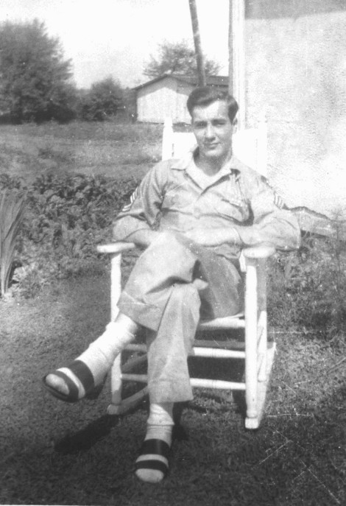
First picture after coming home

I was home a little over two weeks when I came down with a skin infection from my head to my toes. The doctor sent me to a skin specialist in Lancaster. Since I was a service man, he sent me to the army hospital at Valley Forge for treatment. The army doctor said the food I was eating since being liberated was too rich for my body. That, coupled with other things related to being a prisoner, was causing the infections. I was there for two weeks, receiving shots twenty-four hours a day. I had been given a total of a hundred and twenty shots of penicillin. I was also taking boric acid baths several times a day for the two weeks I was there. After several days at home I received orders from the Air Corps. It was for a thirty-day extension of my leave for my stay in the hospital. It also ordered me to report to Kelly Field, San Antonio, TX, on the twenty-fifth, of September 1945, to be discharged. I was to report to Texas because they had closed the Miami Beach base.
Thank goodness for penicillin. I started to break out with boils shortly after I left the Valley Forge Hospital, and counted one hundred and fifty boils from the time I left Valley Forge until almost Christmas of 1945. The toxins in my body were being brought to the surface of my skin by the penicillin. Thus, resulting in skin boils. The doctors said if I hadn’t had the penicillin, the poison in my body could have killed me or made me a very, very sick person. I really had to watch what I ate for quite a long time.
The first memorial for Bill Kirlin was unveiled by Burgomaster De Grauw from Baarle-Nassau (Netherlands) just one year to the day that Bill was killed. The Burgomaster is similar to a mayor of the town. The late Adiaan Van der Hoevenas was the one who initiated the memorial. He was a policeman from Castelre (location where we had crashed). The memorial consisted of a plain wooden cross with a wood kneeling board in front of the cross to kneel on to pray. The cross had Bill’s name and the date of his death on it. Flowers were placed at the foot of the cross, every day.

I reported to Kelly Field on the twenty-fifth of September 1945, to be discharged from the Air Force. I was put into a squadron made up of all Ex-POWs including the squadron commander, who was a pilot with the rank of a major. We were told we would be discharged in two weeks. Two days later we were told we would be discharged by the Army point system. This was the standard military discharge system at the end of the war (if you weren't needed for the war with Japan). Points were awarded for the following; time of service, wounds received, disability, medals earned (Purple Heart I believe was awarded about 10 points, the Air Medal about 5 points), etc. There was no specific compensation (points) for just being a POW. The system said we needed seventy-two points to be discharged. Ninety-five percent of us did not have seventy-two points, and at this time we couldn’t possibly get that many points. Under the circumstances, having only been in the service for less than three years and having spent just over seven months as a POW, I had accumulated less than ten points.
On the third morning, around five thirty a.m., we were awakened by a whistle and someone shouting to get up for a roll call. There in the middle of the barracks stood a private first-class airman, who was blowing the whistle and shouting at us. True this young airman was only doing what he thought he should be doing. However, the rest of us did not see it the same way. The population of the barracks was around fifty former POWs, with the lowest ranking POW there being a staff sergeant. Out of a top bunk came a master sergeant, grabbing the private by his collar and the seat of his pants, and out of the barracks he went.
Fifteen minutes later, in walked our squadron commander and with him was one of the field's one star generals. The private entered again, and the general warned us if this happened again we would all be busted (relieved) of our ranks. The general told us we would stand for roll call at five thirty a.m. in the mornings, then clean our barracks, and drill, and etc. At this time our squadron major became irate and rather emphatically pointed out to the commander some of the hardships we had to endure overseas. I cannot print much more of what was said, as I shall not repeat the profanity and other verbal explicates that were spoken at the time. The final outcome: we got up when we like to, no roll call, no marching. We kept the barracks clean. We still, however, did not know when we would be discharged.
The major told us if any one lived within two hundred miles of the field, they could go home as long as he could get in touch with them and they could get back to the field in a day. We knew it would take three days to get discharged when it came through from the top command. I don’t know just how many went home, but there were quite a few who lived in Texas or the nearby surrounding states. There were about ten of us who went into town and stayed at one of the cheaper hotels just to get away from the brass [commissioned officers] at camp. There were some bad ones there, especially when they knew we were now not being held to the strict Army rules and regulations such as marching, drilling, etc. We all had a free hand as to what we did. I guess we were in town a couple weeks before the major sent a message to the hotel, telling us to be back in camp by the 28th of October. The Army finally changed the POW ruling on getting discharged, realizing that so many POWs didn't have the number of points required, yet nonetheless they needed to go home. This made it possible for us to be discharged immediately. The major wanted four of us to reenlist for another four years and be with him. He was going to be given command of a squadron and wanted four of us to go on with him to be his support staff. We would all be made first sergeants, and be in the states for three years and spend one year overseas. I thought about it, but said "no."
On the morning of the thirty-first of October, I received my discharge at Kelly Air Base in San Antonio, Texas, and that afternoon I was on a train heading home. I was quite anxious to get home. I thought “Hooray…I’m going home the quickest way I can.” I arrived home the second of November, 1945. I was finally a civilian again. I was free!
Summary of Service

Sworn into the Army Air Corps on November 20th, 1942, at the Philadelphia Customs House, Philadelphia, Pennsylvania.
A.S.N. 13154147

Trained and had schooling in the United States until June 26th, 1944.

Served two years and eleven months in the Army Air Corps, in the European Theater.

Departed the United States on June 28th, 1944.

Landed in Valle, Wales on July 4th, 1944.

Flew nine combat missions from August 1st, 1944 until being shot down on September 18th, 1944 over Holland.

Eight months (of the two years and eleven months) as a Prisoner of War in Germany, at Stalag Luft IV.
POW 3692
POW on September 18th, 1944.

Forced march throughout northwest Germany for 86 days.

Liberated May 2nd, 1945, near the town of Lubeck, Germany.

Discharged October 31st, 1945, at Kelly Air Field, San Antonio, Texas.

Awards and Honors

I learned the Army Air Corps had sent my Air Medal and Good Conduct Medal to Pauline while I was overseas.

Air Medal
Good Conduct Medal
2 Service Ribbons
-American Theatre
-European/African/Middle Eastern Theatre (ETO*)
3 Bronze Battle Stars**
-Normandy
-Northern France
-Rhineland battles/campaigns

* ETO stood for the European Theatre of Operation.
** The three Battle Stars were never sent to me, even though my discharge papers showed I was entitled to them.

Epilogue

In the months following the war, I began to look a little more like myself. Getting some weight back on where it was supposed to be…not all in my stomach.

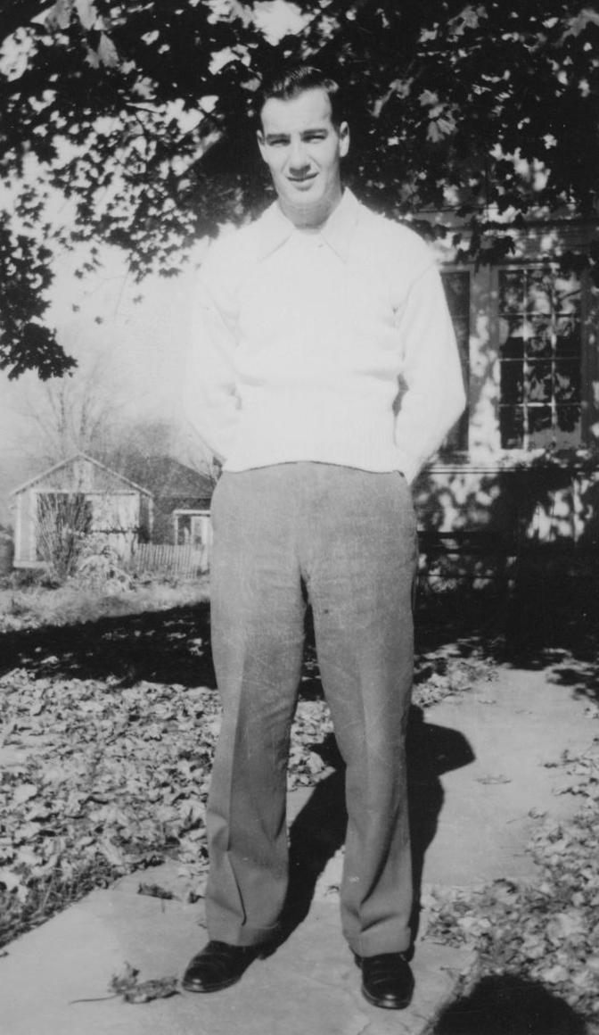
After discharge

In the years following the war, Pauline and I decided it was about time we started a family. Our first daughter, Carol Lynn, was born on June 21st, 1946. Tragically, we lost her in the middle of September 1946 due to complications at childbirth. In August 1947, we had a son, Gary Lee; in April, 1952 another son, Lewis Allen; and finally in October, 1953 another daughter, Theresa Ann.
After leaving the military I was cautioned to not immediately seek work indoors. This was a precaution due to the confinement I experienced as a POW. I eventually worked numerous jobs including a grocery route, painting barns, Luken’s Steel and a paper mill box shop in Downingtown. After spending ten years at the box shop, I was appointed a rural carrier on February the 14th, 1964. Twenty years later I retired from the Postal service as a rural mail carrier on January 3rd, 1984.
Throughout the years following the war I have been active with numerous service clubs and associations. Among these proud activities, I am a past president and lifetime member of the Lion’s Club of Honey Brook, PA; lifetime member of the Veterans of Foreign Wars, Honey Brook; former Scoutmaster of Boy Scout Troop #9, Honey Brook; past commander and lifetime member of the Conestoga Chapter of the American Ex-Prisoners Of War Association (Ex-POW); member of Howell Lodge No. 405, F. & A.M. (Masonic Lodge), Honey Brook, PA; member of the 2nd Air Division Association (United States Air Force); member of the 93rd Bombardment Group (association), member of both the state and national Rural Letter Carriers Association.

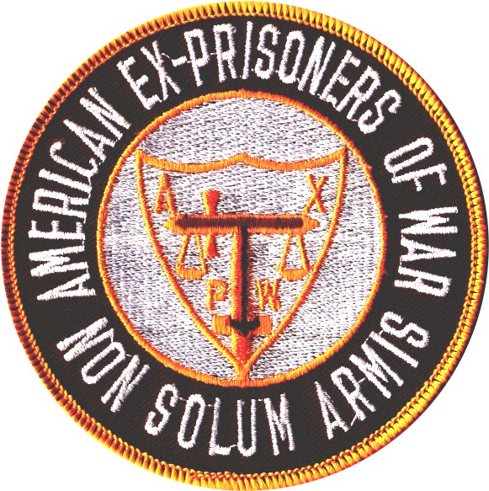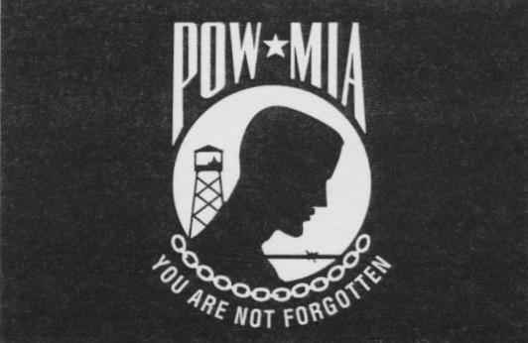

In the latter part of August 1989, after receiving an Ex-POW publication listing each member’s home address, I saw the address of one of the gunners, Eugene Shabatura (Duluth, Minnesota), who was a member of the crew I crashed with in Holland. I started to correspond with him and in September 1989, I also found the co-pilot’s, Richard C. Scott (Pasadena, Texas), address and started corresponding with him, too. This was forty-four years after we were liberated. Little by little, we kept locating more of the crew until June 1993, at which point we had located six out of the nine crew members that had survived for forty-nine years after the crash landing. As mentioned already, crew member Bill Kirlin was Killed in Action (KIA). I learned that crew member Henry Greenberg, of the Chicago, Illinois, died in 1983. Still missing were Stuart Burford, gunner, and James Bolton, supply man (passenger).
On January 6th, 1991 Jos van Roozendaal (from Holland) wrote to Floyd Mabee, who was the Vice President of the 93rd Bombardment Group (association). Jos inquired as to the crew of the B-24 that crash landed in Holland some forty-six years ago. He was looking for any information on the crew. Floyd wrote to each of us and told us about Jos‘ letter he’d received. Floyd wrote he would not give our information to him, but we could correspond with him if we wanted to. It was our choice. Six of us wrote Jos in Holland including myself, Eugene Shabatura, Richard Scott, Larry Hewin (Williamsburg, Virginia), Osborn Malone (Leesburg, Alabama), and George Sadler (Richmond, Virginia). We learned that Jos had wanted to memorialize the death of Bill Kirlin and the last flight of the Baggy Maggy. As it turns out, Jos was born the day that Eugene Shabatura was liberated from the Germans in the spring 1945. Jos and others from his town were very appreciative of our crew, as we were the only Allied troops to crash in or near their town.
From correspondence with Jos, I learned that Doctor Ed Loffeld, a historian from Barrle-Nassau (The Netherlands) started the research for another memorial for Bill Kirlin in the mid 1960s. He did this because the road where we had crash landed had since been relocated. That original site was also where Bill was initially buried at. As a result of the relocation, the first memorial cross was never located. Also, Doctor Loffeld passed away in 1983 with little success for a new memorial for Bill.
The next try for the memorial came from three members of the local historical society from Barrle-Nassau. They were Ed Ragas, Jos van Roozendaal, and Arie P. de Jong. These three men didn’t get any more cooperation than the doctor before them, but they did not give up pursuit for a new memorial. Jos van Roozendaal decided to try and get in touch with the crew of Baggy Maggy. Once he made contact with us, he did extensive research about the Baggy Maggy and our crew.

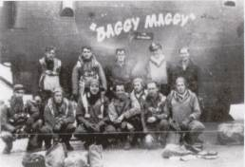
Unknown previous Baggy Maggy Crew

This is one of the crews that had flown the Baggy Maggy prior to September 18th, 1944. I believe there were three or four other crews that had flown in this B-24 before her final flight. In 1993, I received a letter from an engineer, whose crew flew the Baggy Maggy on several missions. He inquired as to what happened to the plane called the “Baggy Maggy.” He had sent this picture of their crew with the Baggy Maggy. I told him about the mission that day, and that we had to crash land the Baggy Maggy. I told him the Germans had destroyed the plane after they had taken everything they could from the plane. They even pumped the gas out of the tanks on the plane. Fifty years later I learned this, according to the people who live near where we crashed. I also learned the Germans burned the plane when they were done with it. I used this picture because I never had a picture of the plane.
June 30th, 1993, was the first time after forty-nine years five members of Larry Hewin’s crew came face-to-face with each other at a reunion hosted by the bombardier, George and his lovely wife Wilton Sadler, at their home in Richmond, Virginia. The five men who were present at the reunion were: host George Sadler, bombardier; Larry Hewin, pilot; Richard Scott, copilot; Eugene Shabatura, gunner; and myself, flight engineer and gunner. Although Ozzie Malone had also been in contact with us, he was unable to attend the reunion due to health problems.

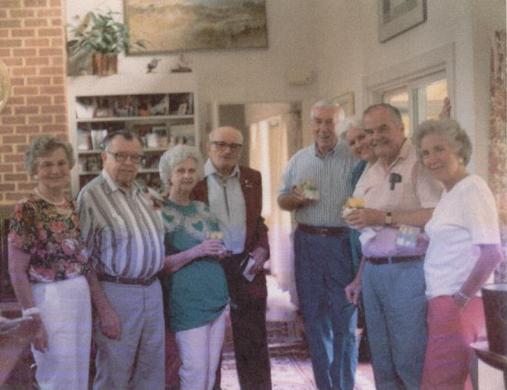
Reunion June 3rd, 1993
From left: Pauline Dukeman, Richard Scott, and Lucy Faye Scott
Eugene Shabatura, Larry Hewin, Barbara Hewin, George Sadler, and Wilton Sadler. I was the photographer.

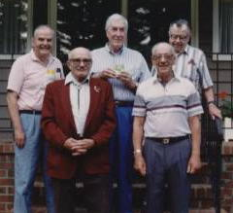
Back row, from left: George Sadler, Larry Hewin, Richard Scott.
Front row, from left: Eugene Shabatura, Donald Dukeman.

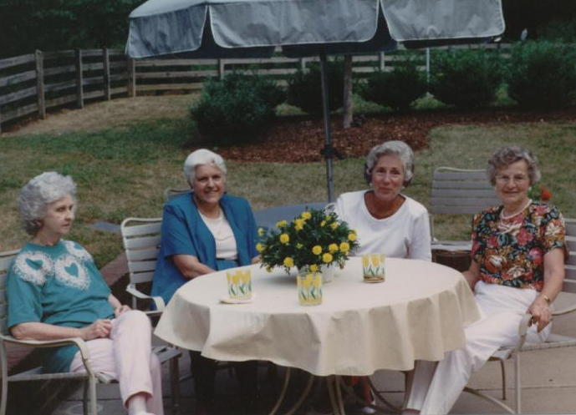
From left: Lucy Faye Scott, Barbara Hewin,
Wilton Sadler, Pauline Dukeman.

Shortly after the reunion, George Sadler found Stuart Burford another member of the crew, in Kenswick, Virginia. We never found James Bolton, the supply man.
Early spring 1994, the entire crew received notification that the people of Barrle-Nassau had succeeded in getting the go ahead to dedicate a new memorial for Bill Kirlin. The officials of the towns invited all of us to visit Holland and join with them in celebrating the fiftieth anniversary of their liberation, as well as to participate in the dedication of the new memorial for Bill Kirlin. Present at the anniversary ceremony and dedication of the new memorial stone on (September 18th, 1994), were Richard Scott, Lucy Faye Scott, George Sadler, Eugene Shabatura, Mrs. Stuber (Bill Kirlin’s sister), and Mrs. Stuber’s daughter-in-law. At first there was a church service, and then there was a parade to the crash site where the dedication of the new memorial stone was held. The dedication occurred at the exact time that we crashed in that same field fifty years ago in 1944. Those crew members who attended were each presented with a copy of the Baggy Maggy File, which contained the research of the crew and the crash, compiled by Ed Ragas and Jos van Roozendaal.

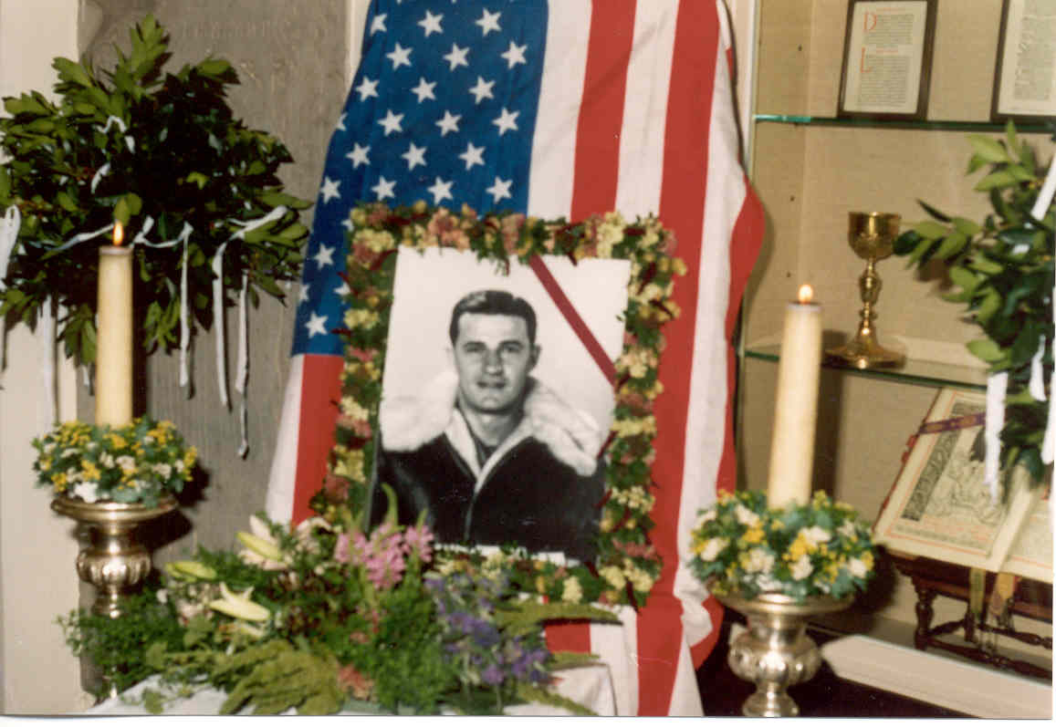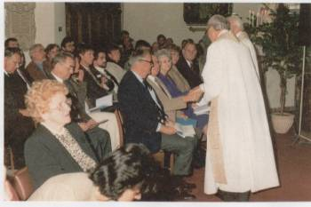
Church service in Holland, September 18th, 1994.

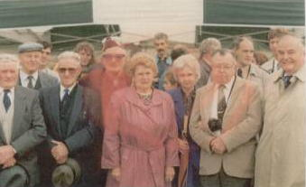
Front row, from right: George Sadler,
Richard Scott, Lucy Faye Scott, Mrs. Stuber,
Eugene Shabatura (in red ExPOW coat), and
other people from the community.

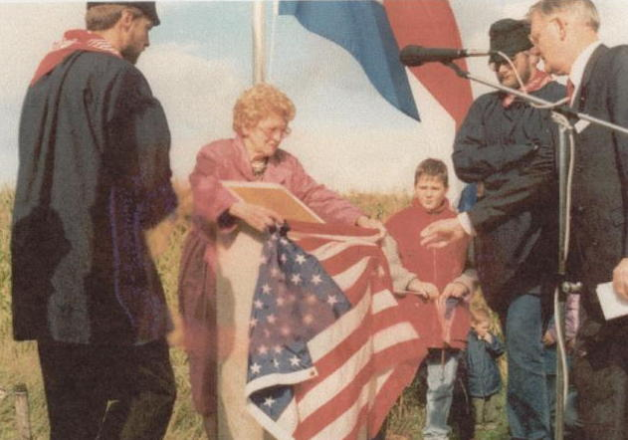
Mrs. Stuber removing the flag to unveil
the memorial.

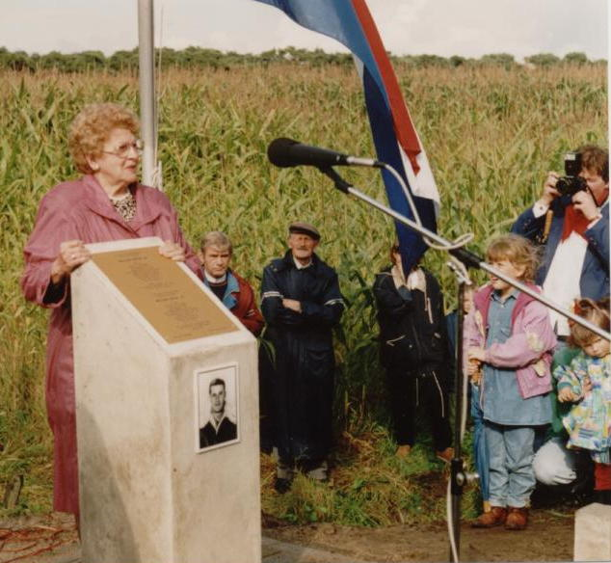
Mrs. Stuber’s address at the unveiling.

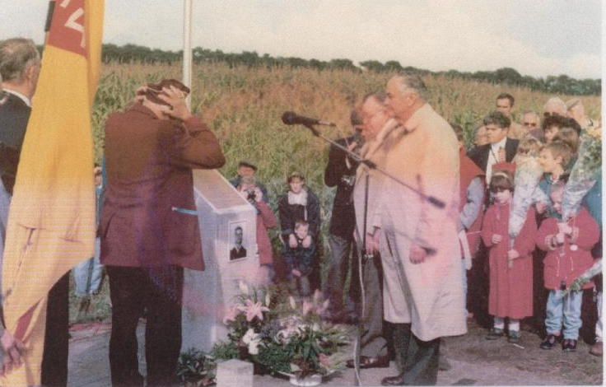
After the address by Mrs. Stuber, Eugene
and George show their respect and the
children placed flowers at the memorial.

The memorial is located at a spot in the field where we came to rest after the crash. Those who attended the dedication enjoyed the visit and the celebration with the Hollanders. However, the visit also brought back many memories of the fatal crash that occurred that Monday afternoon over fifty years ago, as well as memories of the eight months we spent as German POWs.

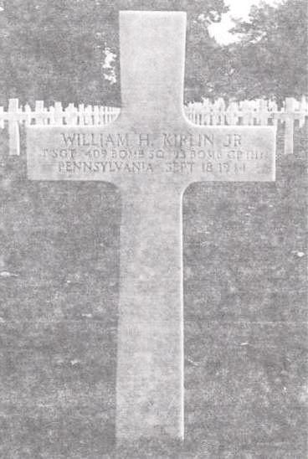
This is the final resting place for Bill Kirlin.

“American Cemetery the Netherlands”
At Maastricht in southeast Netherlands
(between Aachen and Maastricht).

On June 3rd, 1995, I was invited to be the guest speaker for the unveiling of the POW & MIA (Prisoner of War & Missing in Action) Stamp at the Stevens Post Office in Steven, Pennsylvania. This would be the first time I spoke of the crash and my imprisonment publicly. A few years ago the POW Medal was created and sanctioned by the armed services. I made application for the medal, and shortly thereafter I was awarded the POW Medal.

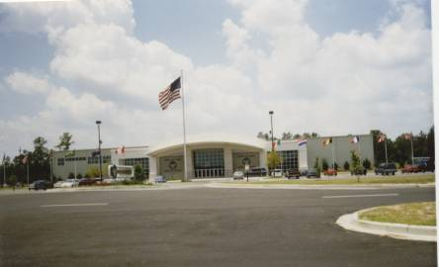
The Mighty Eighth Air Force Heritage Museum
Savannah, Georgia

Museum Logo

On May 13th and 14th, 1996, The Mighty Eighth Air Force Heritage Museum was opened to the public in Savannah, Georgia. In June 1996, my grandson, Gary L. Dukeman, Jr. and his family visited the museum on their way to Pennsylvania for their vacation. Gary learned of a memorial wall program called the “Wall of Valor,” whereby Eighth Air Force Veterans were being memorialized through an engraved marble plaque affixed to large marble and granite walls in the memorial garden at the museum. Gary was so intrigued with the museum that he visited it again on his way back home to Florida. However, prior to his leaving Pennsylvania, he discussed the “Wall of Valor” program with our other grandchildren. They all decided to chip in and purchase a memorial plaque to honor me.
Pauline and I have visited the museum three times ourselves and we think the museum and memorial garden are very good for as long as it has been opened. Compared to some other museums we have visited, it is a much better museum. It is well kept and contains a lot of memorabilia and unit history items as well as a library. We have been told that since the last time we were there the chapel is already built or well on the way to being completed. There is a stained glass window to be put in the chapel that was donated from the area we flew out of in England during the war.
Each year, curators of the museum add so many more new memorials and artifacts from the different groups that served in the Eighth Army Air Force in W.W.II. Many displays are of the fighter groups and the bomber groups. Area schools are also using the museum in order to help educate the children about the war and other parts of the history of our country. There is a very good library there, too. One of the memorial plaques on the “Wall of Valor” recognizes Lt. Larry Hewin’s Crew. The following pictures will be those of the memorial garden, pool, memorial walls and wall plaques.

Memorial garden and reflection pool.

The memorial garden is made up of marble and granite plaques affixed to stone walls, creating the “Walls of Valor.” Our names and groups are engraved on the plaques. At the time there are about six walls with names on both sides of the walls.

Tombstone and memorial for General James
H. Doolittle. These memorials were the first
donated to the museum’s memorial garden.

The tombstone pictured above is the original headstone from General Doolittle’s burial site at Arlington National Cemetery. His family donated the headstone to The Mighty Eighth Air Force Heritage Museum for the grand opening and dedication of the Museum. By the end of World War II, General James H. Doolittle was the Supreme Commander of all the Air Force in Europe.

One of the memorial walls located in the
memorial garden. Names are displayed
on both sides of walls.

I am pointing to Larry Hewin’s Crew Plaque

Group and crew plaques on memorial wall

Pointing to my plaque on the wall

Fighter group plaque

B-17 bomber crew memorial

Resting and prayer bench

More wall memorials and a portion
of the reflection pool.

In the early part of 2000, I received an e-mail from Jos, informing me that his son was currently in Tucson, Arizona attending flight school. He completed his book work in Holland; however, the weather there was too poor to learn how to fly. Thus, he would be in Arizona until around the first of November or December. Jos said he and his wife Adrienne may visit from Holland to see his son and some of the United States while they were here. During the middle of August, I received another e-mail stating they would be in the states for about four weeks. They had to leave to go back to Holland on October 4th, departing from Huston, Texas. They planned to visit Scotty and Lucy Faye on the 3rd of October.
Pauline and I had not yet had the pleasure of meeting Jos and Adrienne. So, I e-mailed them back stating if nothing happened in the meanwhile, we would try to meet them at Scotty’s and Lucy Faye on the 3rd of October in Pasadena, Texas. Scotty and Lucy Faye were able to visit Holland for the fiftieth anniversary of our liberation and the fiftieth anniversary of our crashing in Holland on September 18th, 1994.
On October 1st, 2000, we arrived at Scotty’s and Lucy Faye’s home. We used their spare bedroom, staying with them for four days. On the 3rd of October, we had about a ten hour visit with Jos and Adrienne. What a wonderful time we had with Scotty and Lucy Faye, Jos and Adrienne. As we all said, it was an awful short visit, but we did a lot of remembering and for Pauline and me, it was our first meeting with Jos and Adrienne. We will never forget it. Nor will we forget Jos and Adrienne, so far away Holland, yet they are part of our family now.

October 3rd, 2000 at Scotty and Lucy Faye’s home in Texas
Back row, from left: Lucy Faye Scott, Pauline Dukeman.
Front row, from left: Jos & Adrienne Roozendaal,
& Richard Scott.

Back row, from left: Jos & Adrienne van Roozendaal
Front row, from left: Donald Dukeman, Richard C. Scott,
Lucy Faye Scott

The BALL OF FIRE QUARTERLY EXPRESS, newsletter of the 93rd Bombardment Group, informed its members in the winter 2000 edition, that the 93rd Bomb Group was holding a reunion at The Mighty Eighth Air Force Heritage Museum, in Savannah, Georgia, on March 30-31, and April 1-2, 2001. During the reunion, we would be dedicating a bronze bust of General Edward J. “Ted” Timberlake to the museum and a 93rd Bomb Group plaque to the Memorial Garden. This would be the first reunion ever held for just the 93rd Bomb Group members. Other reunions have been held, but all of the Air Force groups in the 2nd Air Division, 8th Air Force, were able to attend those reunions.
Pauline and I drove to Savannah to attend the reunion. Our grandson, Gary Jr., drove from Florida and met us at the motel to be a guest with us at the reunion. There were one hundred and fifty-five 93rd Bomb Group members present at this reunion. Most, if not all, were World War II Veterans. Those of us who attended the reunion had a great time. They had a hospitality room for us each night, a riverboat brunch cruise, and a great banquet the last night for the dedication of General Timberlake’s Memorial Bust. On the last day, we presented the group plaque in the memorial garden. That was the last event of the reunion. Now for more picture taking.

I am the fourth from the left, wearing my red Ex-POW blazer.

Grandson Gary, Pauline and I at the
memorial garden

Pauline and I at the garden pool

Grandson Gary Jr. and I by the pool

This is the grandson who hounded me about doing a diary on my W.W. II and POW experiences. He is very interested in the history of W.W.II and in The Mighty Eighth Air Force Heritage Museum
Below is a picture of the memorial plaque my grandchildren so thoughtfully donated to the memorial garden in my honor. Thank you for honoring me this way. I love you all very much and hope you’ve enjoyed reading these memoirs.

After the reunion was over, we followed Gary over to Andersonville, Georgia, where the American Prisoner of War Museum was located. It had opened several years ago. We toured the museum, but I did not think too much about this museum. It contained more about the Civil War Prisoners and it is mostly documents and photos. We spent about one hour there and that was enough to see everything. I was very disappointed. Perhaps some day the museum will be expanded to provide a more comprehensive look at the trials and experiences of POWs in all the wars. We left there and followed Gary to Florida, stopping at Pauline’s brother and wife’s home for several days. From there we visited very good friends in Ft. Myers overnight, and then headed for Gary’s home. We visited him and his family for several more days then returned home to Pennsylvania.
Pauline and I have been married fifty-eight years this past February 19th, 2002. Our children blessed us with grandchildren, and they with great-grandchildren. We now have four granddaughters, three grandsons, two step-grandsons, and four great-grandsons, and three great-granddaughters. With family and spouses the total of Pauline's and my family so far is thirty. There are still five grandchildren who are not yet married.
As of this date, June 2002, there are only four crew members known to be still alive. Pilot Larry Hewin, copilot Richard C Scott, gunner Stuart Burford, and flight engineer/gunner Donald Dukeman. Larry is still living in Williamsburg, Virginia, Richard in Pasadena, Texas, and Stuart in Kenswick, Virginia. We have no information on the supply sergeant, Sergeant James Bolton, as to whether he is alive or dead. Eugene Shabatura passed away in December 1994. Osborn “Ozzie” Malone passed away in the mid 1990s. George Sadler passed away in the mid-to-late 1990s.
As far as any contact with my original crew, the ones whom I flew overseas with, I lost contact after I was shot down with the Hewin Crew. Only a few years after the war, I had the opportunity to visit John David Jr. at his home in Richmond, Virginia. We corresponded for a few years thereafter. I learned John passed away in early 1993. In the late 1940s, I received an invitation to attend Forrest Holbrook’s wedding to be held in New York. I was unable to attend due to the birth of my son Gary. I also had some correspondence with Forrest Lam throughout the 1990s until he passed away in the late 1990s. Forrest Lam had been living in the San Francisco, California area. I have no other information on any of the other crew members.

As the Germans told us when we were captured…

The war is ---- KAPUT ---- It is done for us.

My diary is ---- KAPUT ---- It is written.

